

**PRATHMESH PATIL**

**A71004819033**

**BCA SEM4**

**UNIX**

AMITY UNIVERSITY MAHARASHTRA

Amity Institute of Information Technology

This is to certify that Mr. Prathmesh Patil is a Bonfire student of Amity Institute of Information Technology, at Amity University Maharashtra and he has done the project work titled “Unix” at Amity University Mumbai as prescribed by AIIT, AUM in partial fulfilment of the requirement of BCA Program for the academic year 2021-22.

Teacher’s signature :-

**INDEX:-**

|  |  |  |  |
| --- | --- | --- | --- |
| Index No | Experiments | Page |  |
| 1 | Write a Shell Script that takes a search string and filename from the terminal & display the results. | 6 |  |
| 2 | Write a Shell Script that takes pattern and filename as command line arguments and displays the results appropriately i.e pattern found/ pattern not found | 7 |  |
| 3 | Write a Shell Script that accepts only three arguments from the command line. The first Argument is the pattern string, the second argument is the filename in which the pattern is to be searches and the third argument is the filename in which the result is to be stored. | 8 |  |
| 4 | Write a Shell Script that accepts a filename as a command line argument and finds out if its a regular file or a directory. If its a regular file, then performs various tests to see if it is readable, writeable, executable etc. | 9 |  |
| 5 | Write a shell script which creates the following menu and prompts for choice from user and runs the chosen command | 10 |  |
| 6 | Write a shell script that computes the factorial of a given number | 12 |  |
| 7 | Write a shell script that words like a calendar reminding the user of certain things depending on the day of the week | 13 |  |
| 8 | Write a Shell Script that changes the extension of a group of files from txt to doc. | 14 |  |
| 9 | Write a Shell Script that accepts both filename and a set of patterns as positional parameters to a script. | 15 |  |
| 10 | Write a Shell Script which will redirect the output of the date command without the time into a file. | 16 |  |
| 11 | Write a Shell Script (using while loop) to execute endlessly (until terminated by user) a loop which displays contents of current directory, disk space status, sleep for 30 seconds and display the users currently logged in on the screen. | 17 |  |
| 12 | Write a Shell Script that receives two filenames as arguments. It should check whether content of the two files is same or not. If they are same, second file should be deleted. | 18 |  |
| 13 | If a number is input through the keyboard, WASS to calculate sum of its digits. | 19 |  |
| 14 | Write a Shell Script that performs a count-down either from 10 (default) or from the value that is entered by the user. | 20 |  |
| 15 | Write a Shell Script which takes a command line argument of Kms and by default converts that number into meters. Also provide options to convert km to dm and km to cm. | 21 |  |
| 16 | Write a Shell Script using for loop, which displays the message "Welcome to the UNIX System". | 22 |  |
| 17 | Write a Shell Script to change the filename of all files in a directory from lower-case to upper-case. | 23 |  |
| 18 | Write a Shell Script that examines each file in the current directory. Files whose names end in old are moved to a directory named old files and files whose names end in .c are moved to directory named c programs. | 24 |  |
| 19 | Write a Shell Script which searches all files in the given directory (to be taken as command line argument) for the file having the title (to be taken as command line argument), as the first line in the file. a) Display the contents of the searched file. b) In the end, print the file is ###, where### is small-sized if total no. of lines is <50### is medium-sized if total no. of lines between 50&100 ### is large-sized. | 25 |  |
| 20 | Write a shell script which reports names and sizes of all files in a directory(directory would be supplied as an argument to the shell script) whose size is exceeding 1000 bytes. The filenames should be printed in descending order of their sizes. The total number of such files should also be reported. | 27 |  |
| 21 | WASS for renaming each file in the directory such that it will have the current shell PID as an extension. The shell script should ensure that the directories do not get renamed | 28 |  |
| 22 | WAP to calculate and print the first m Fibonacci numbers. | 29 |  |
| 23 | WASS that will receive any number of filenames as arguments. The shell script should check whether such files already exist. If they do, then it should be reported. The files that do not exist should be created in a sub-directory called mydir. The shell script should first check whether the sub-directory mydir exists in the current directory. If it doesn’t exist, then it should be created. If mydir already exists, then it should be reported along with the number of files that are currently present in mydir. | 30 |  |
| 24 | A shell script receives even number of filenames. Suppose four filenames are supplied, then the first file should get copied into second file, the third file should get copied into fourth and so on. If odd number of filenames is supplied then no copying should take place and an error message should be displayed. | 33 |  |
| 25 | WASS to identify all zero-byte files in the current directory and delete them. Before proceeding with deletion, the shell script should get a conformation from the user. | 35 |  |
| 26 | WASS to compute the GCD and LCM of two numbers. | 37 |  |
| 27 | Two numbers are entered through the keyboard. WAP to find the value of one number raised to the power of another. | 38 |  |
| 28 | WASS that prompts the user for the password. The user has maximum of 3attempts. If the user enters the correct password, the message “Correct Password” is displayed else the message “Wrong Password”. | 39 |  |
| 29 | WASS that repeatedly asks the user repeatedly for the “Name of the Institution” until the user gives the correct answer. | 41 |  |
| 30 | WAP to generate all combinations of 1, 2 and 3 using for loop. | 42 |  |

Q1. Write a Shell Script that takes a search string and filename from the terminal & display the results.

Code :-

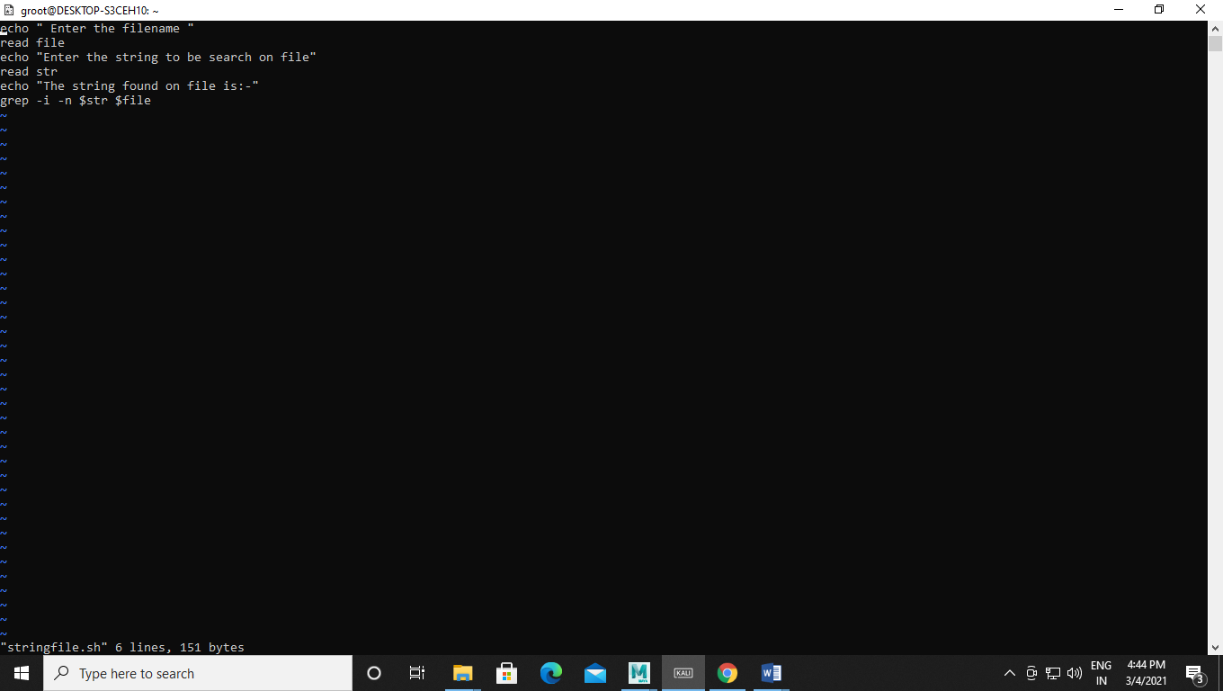

Output:-

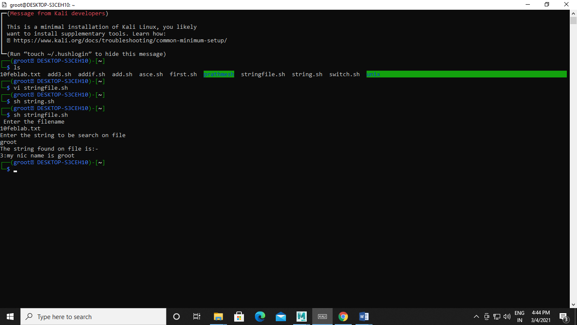

Q2. Write a Shell Script that takes pattern and filename as command line arguments and displays the results appropriately i.e pattern found/ pattern not found

Code :-

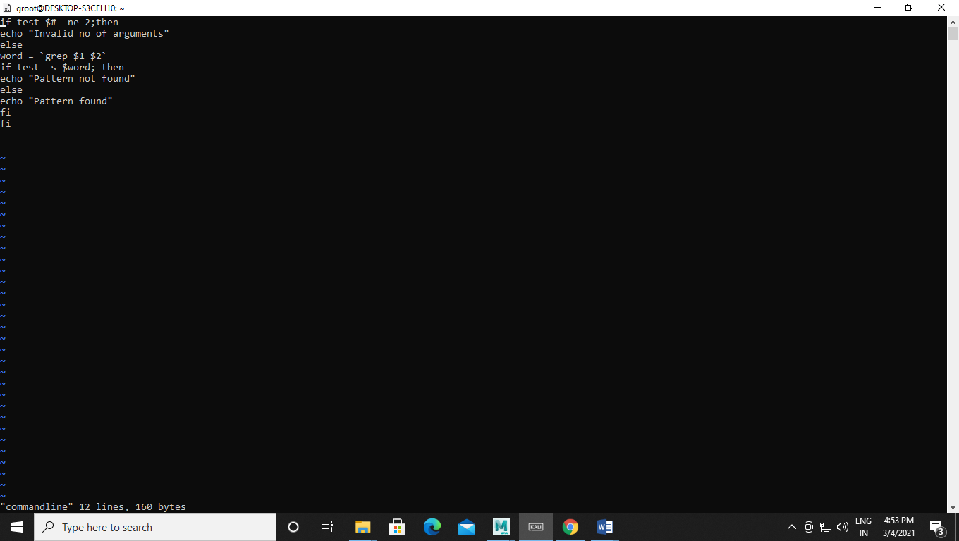

Output:-

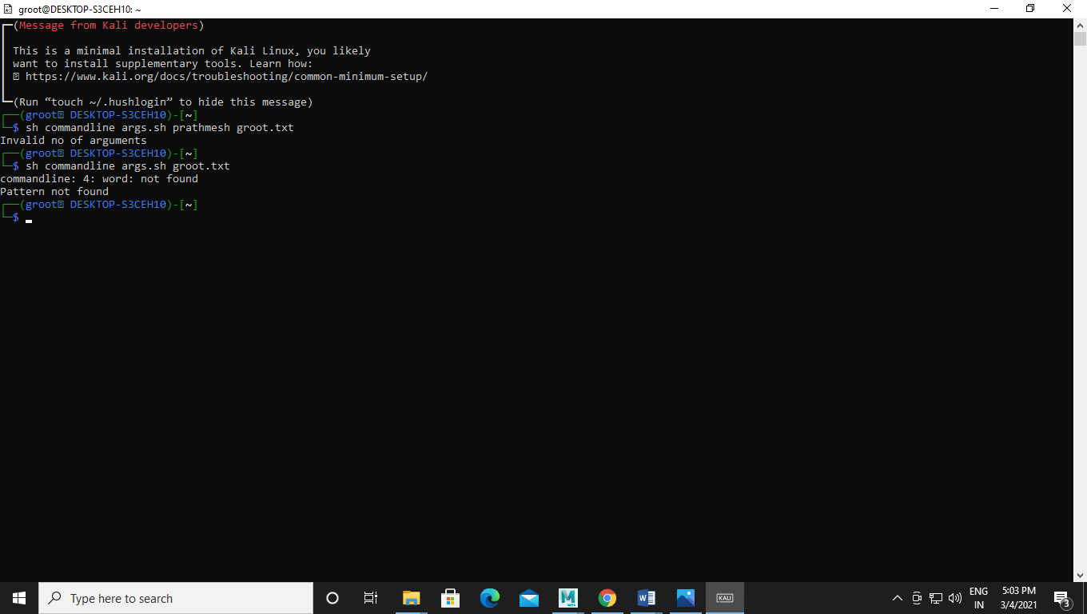

Q3. Write a Shell Script that accepts only three arguments from the command line. The first Argument is the pattern string, the second argument is the filename in which the pattern is to be searches and the third argument is the filename in which the result is to be stored.

Code:-

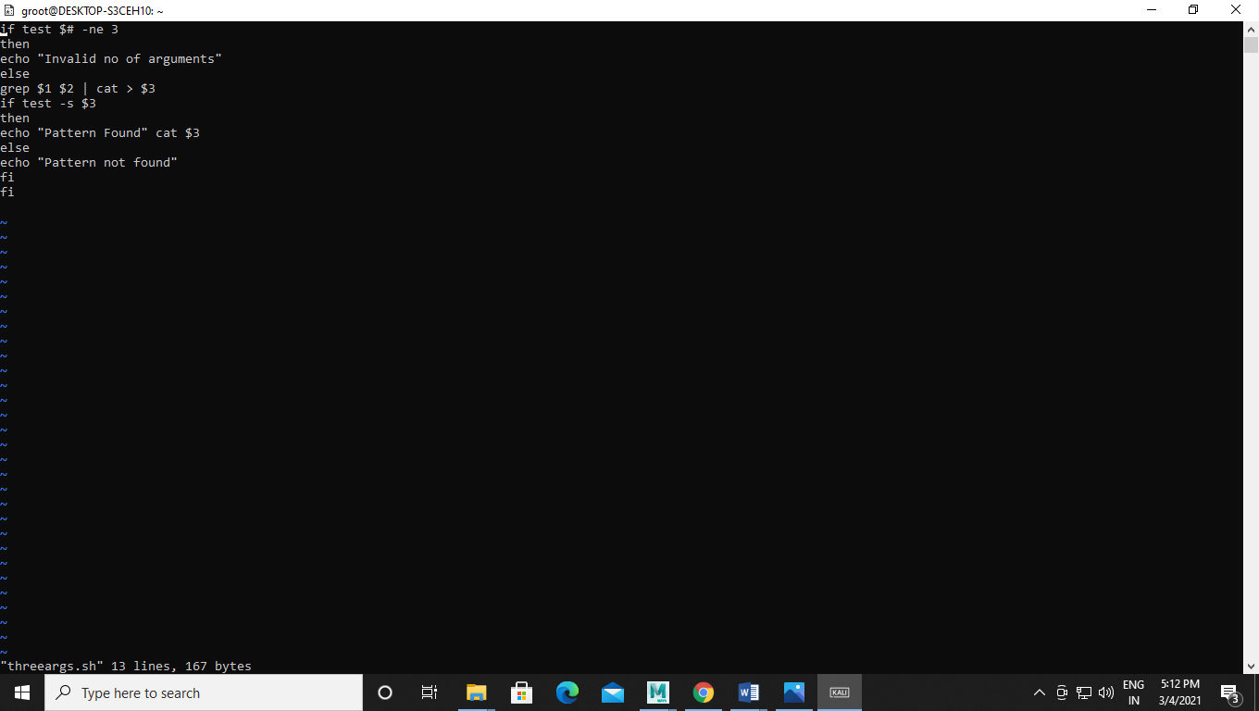

Output:-

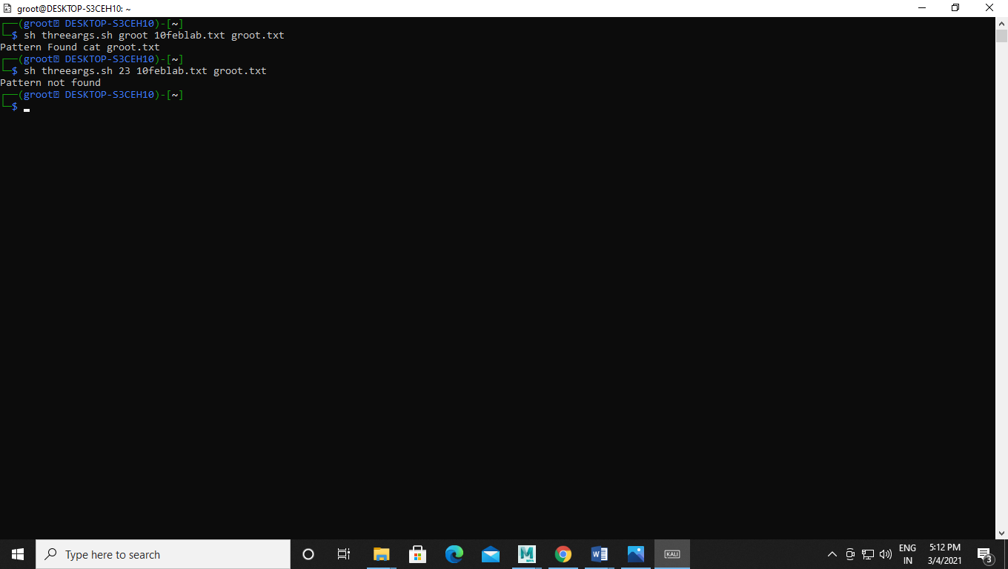

Q4. Write a Shell Script that accepts a filename as a command line argument andfinds out if its a regular file or a directory. If its a regular file, then performs varioustests to see if it is readable, writeable, executable etc.

Code:-

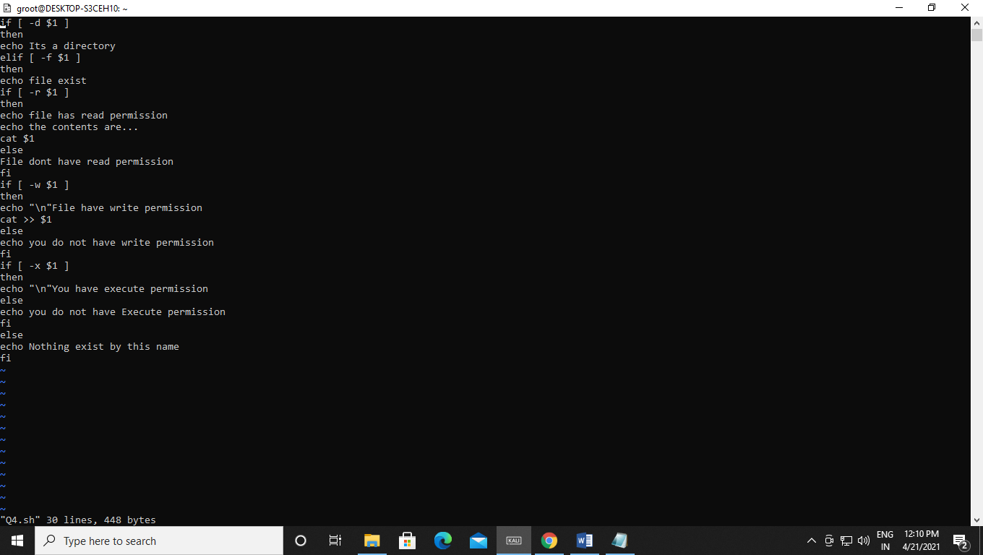

Output:-

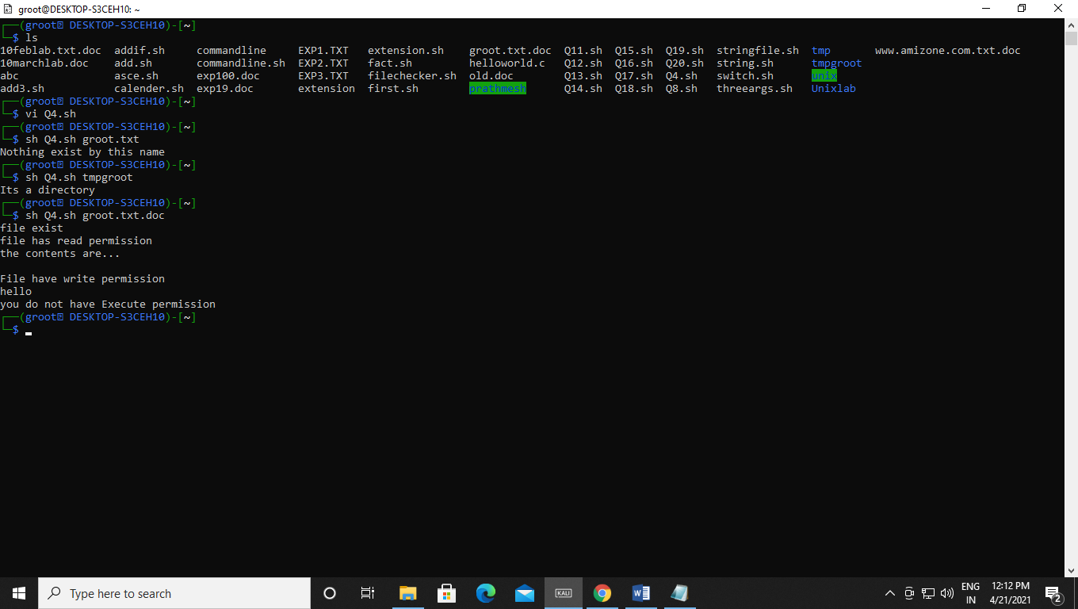

Q5. Write a shell script which creates the following menu and prompts for choice from user and runs the chosen command

Today’s date

User name

Process of user

List of files

Quit

Code:-

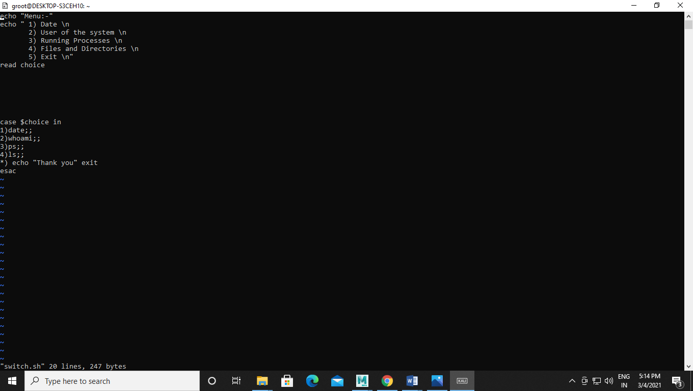

Output :-

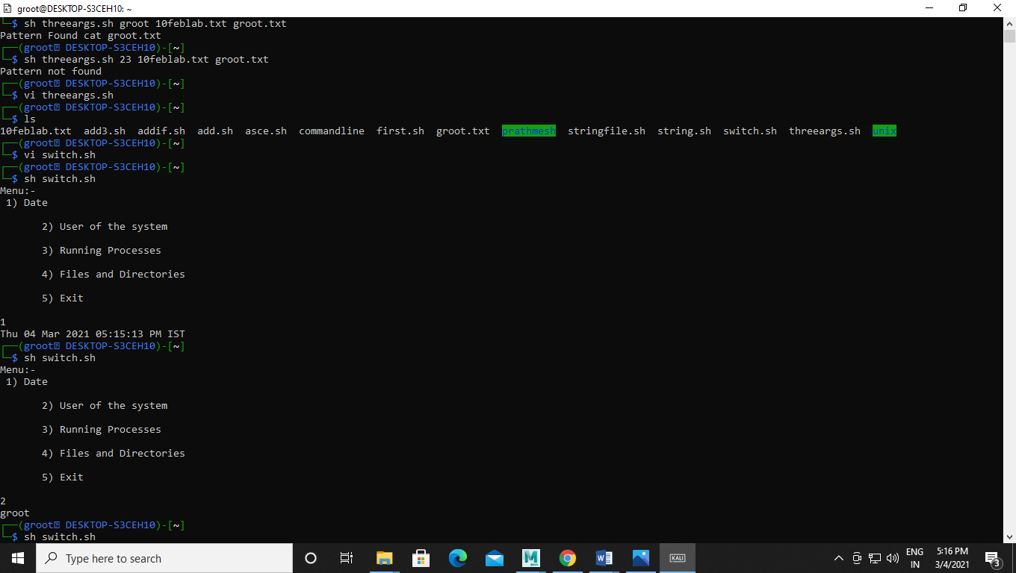

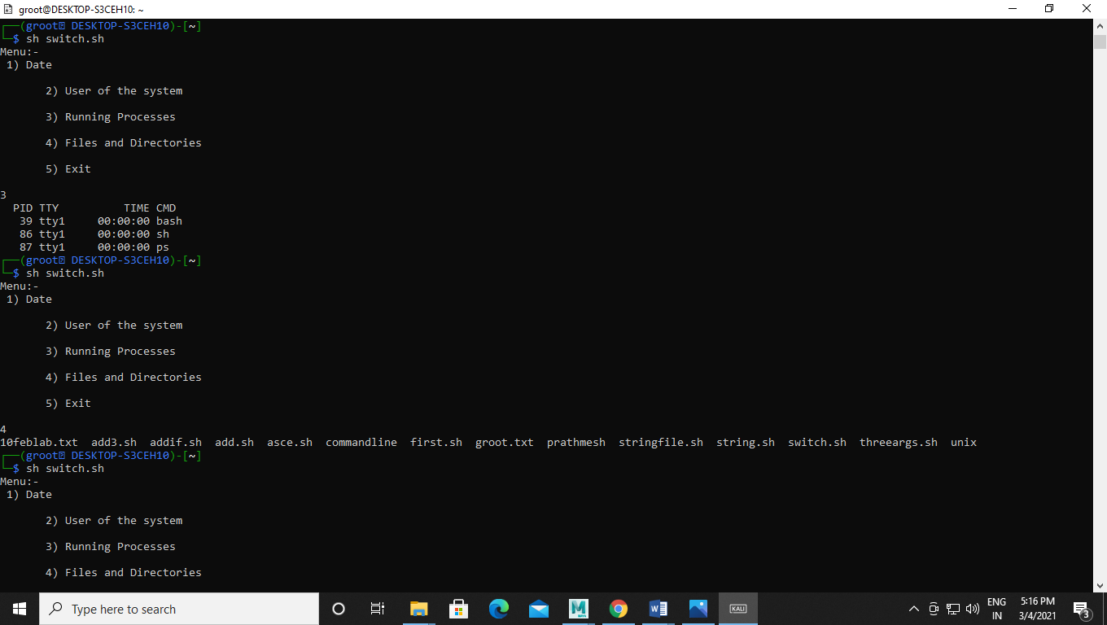

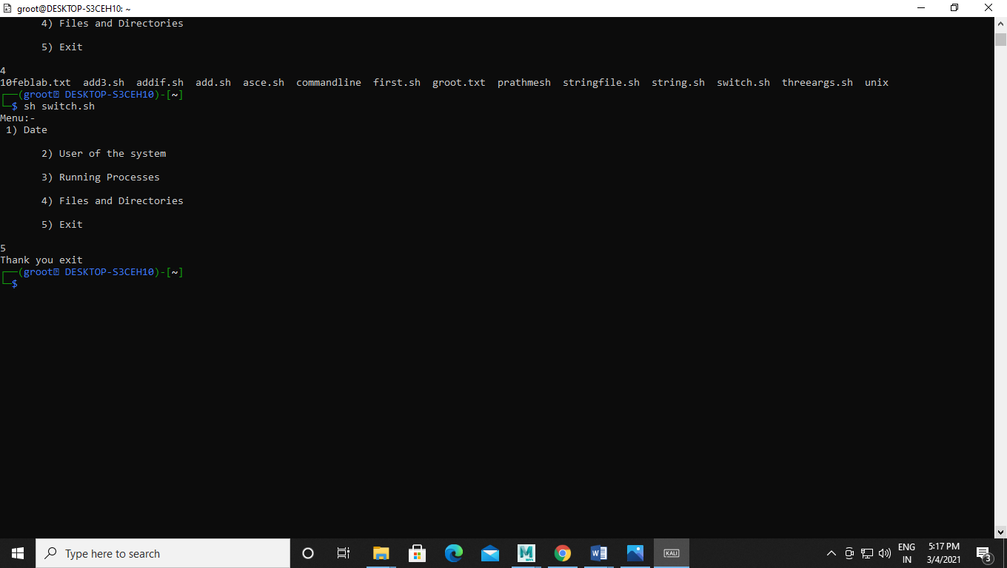

Q6. Write a shell script that computes the factorial of a given number

Code :-

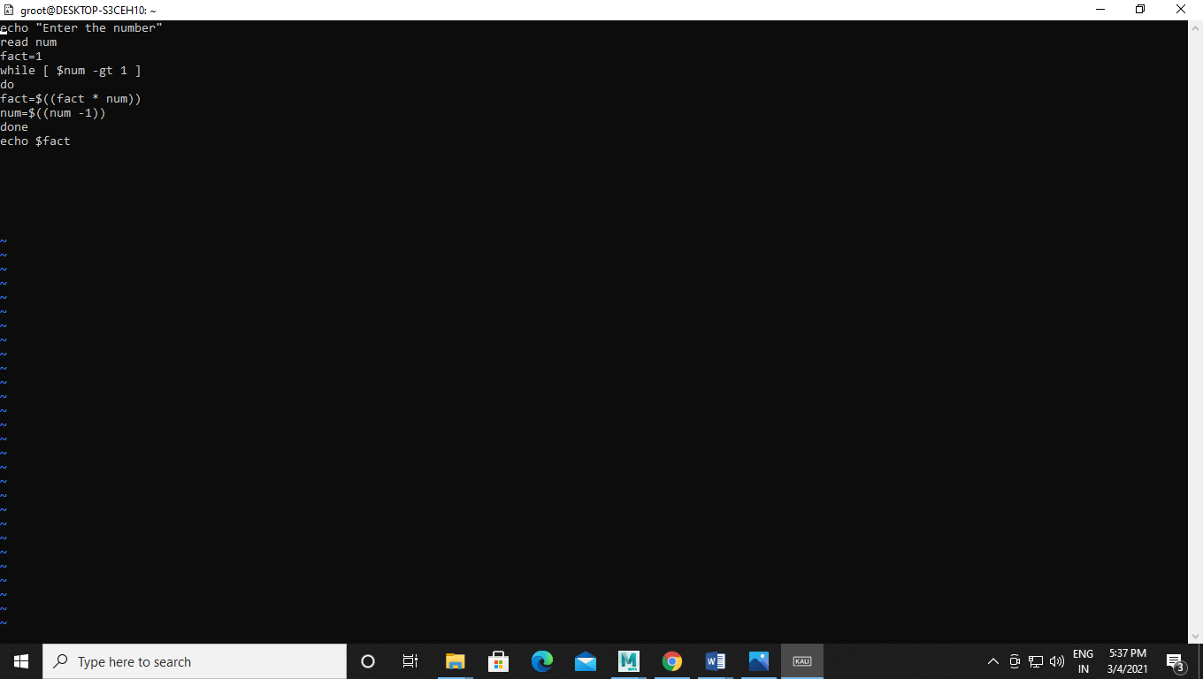

Output:-

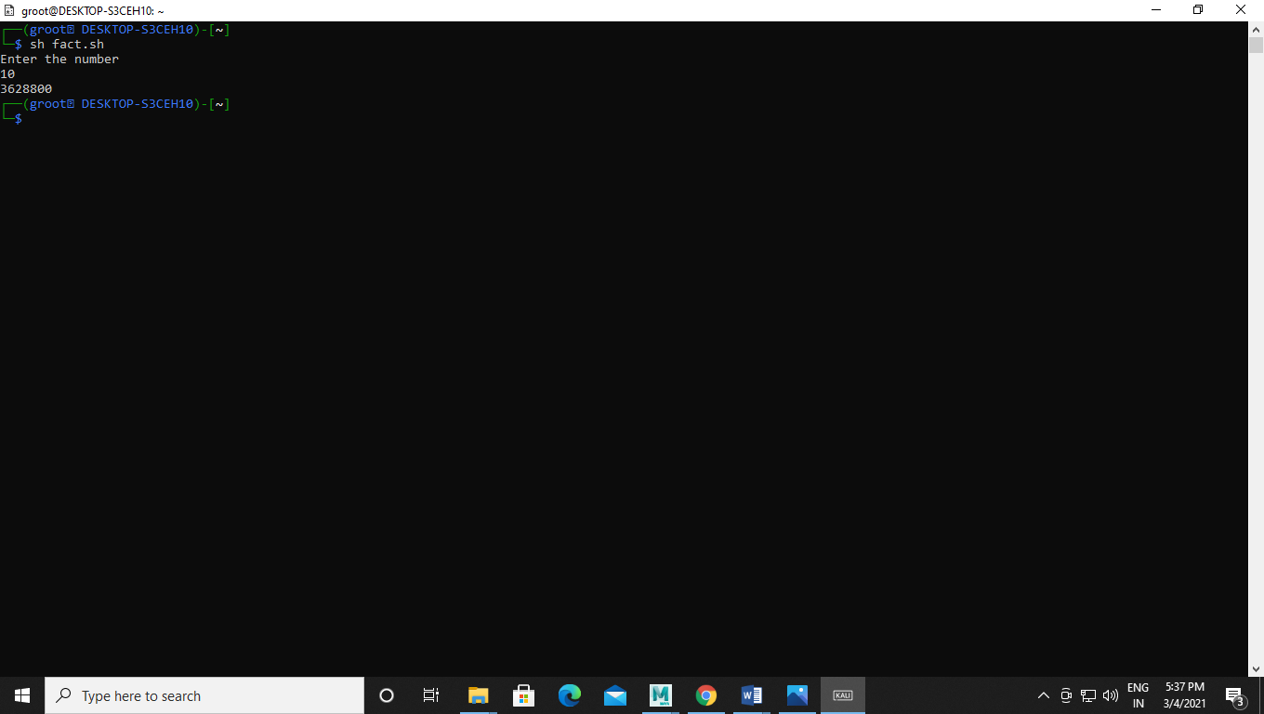

Q7. Write a shell script that words like a calendar reminding the user of certain things depending on the day of the week

Code:-

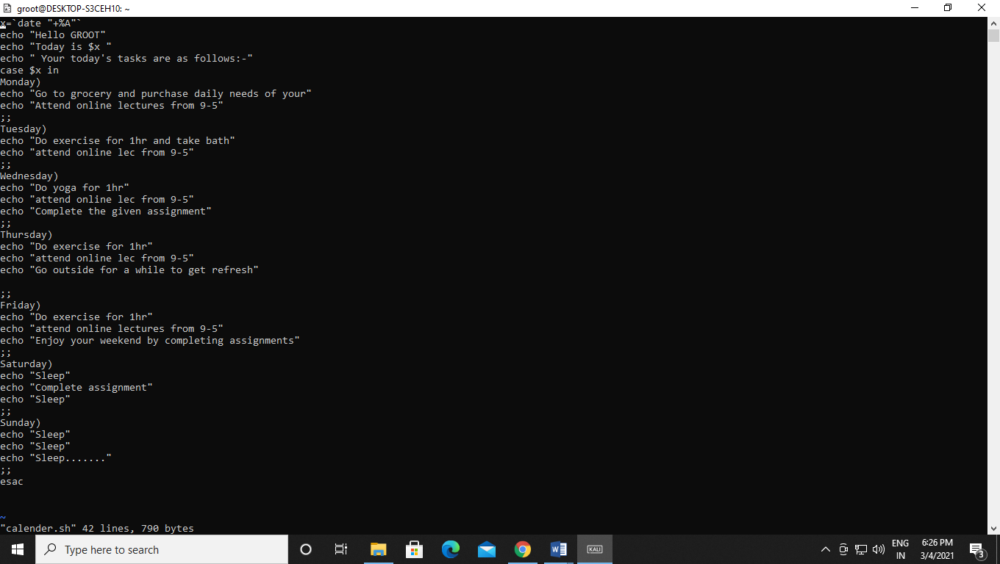

Output:-

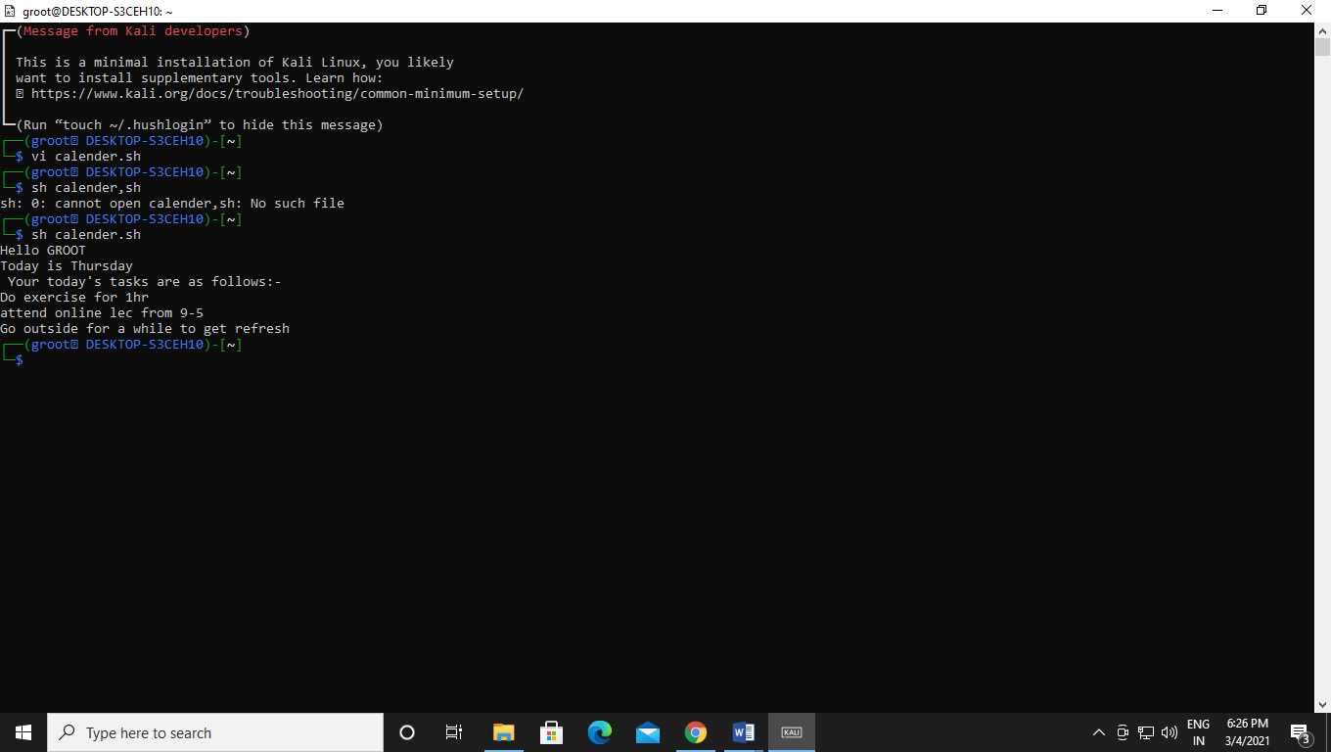

Q8. Write a Shell Script that changes the extension of a group of files from txt to doc.

Code:-

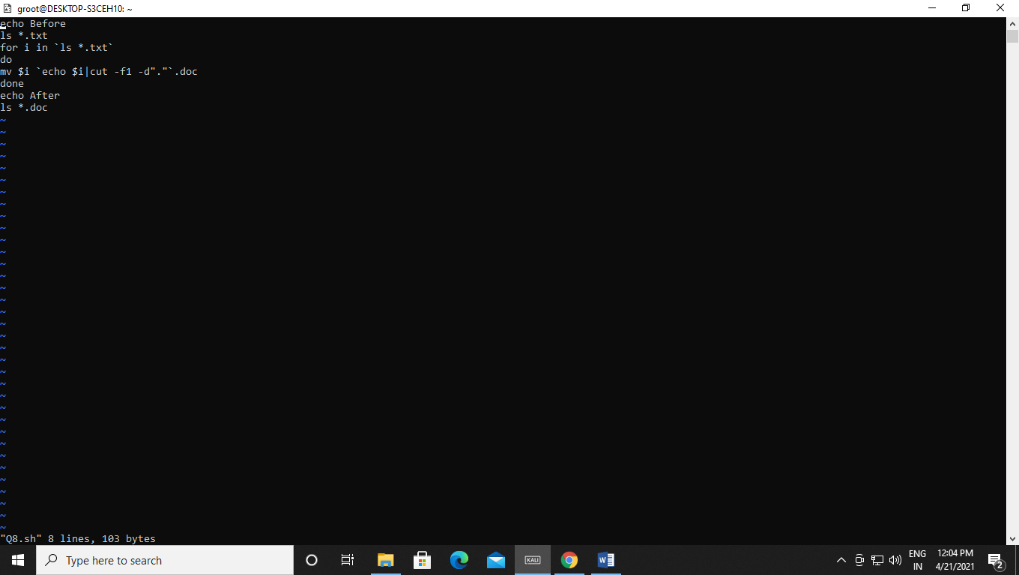Output:-

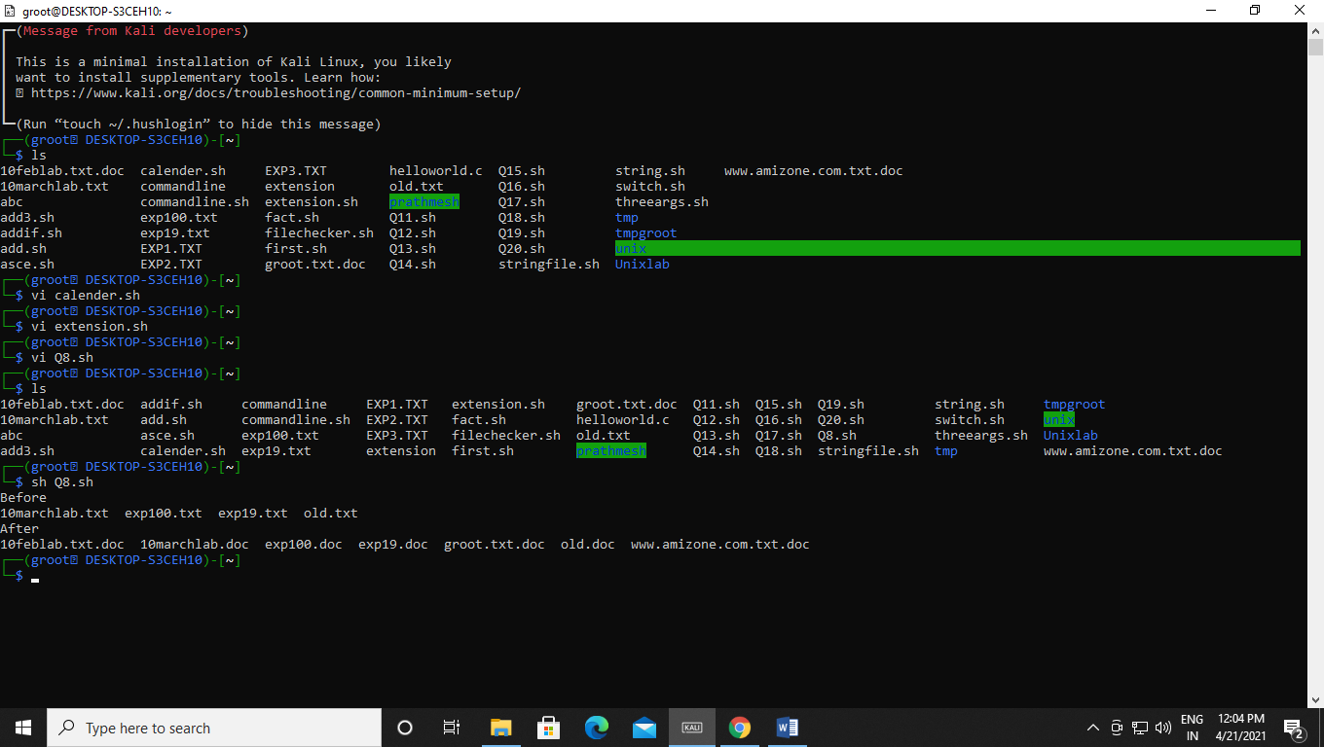

Q9. Write a Shell Script that accepts both filename and a set of patterns aspositional parameters to a script.

Code:-

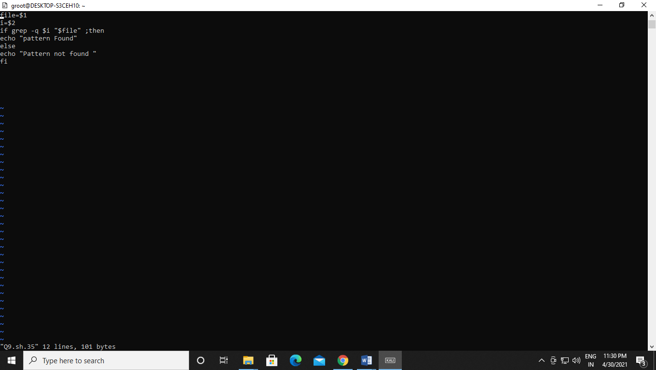Output:-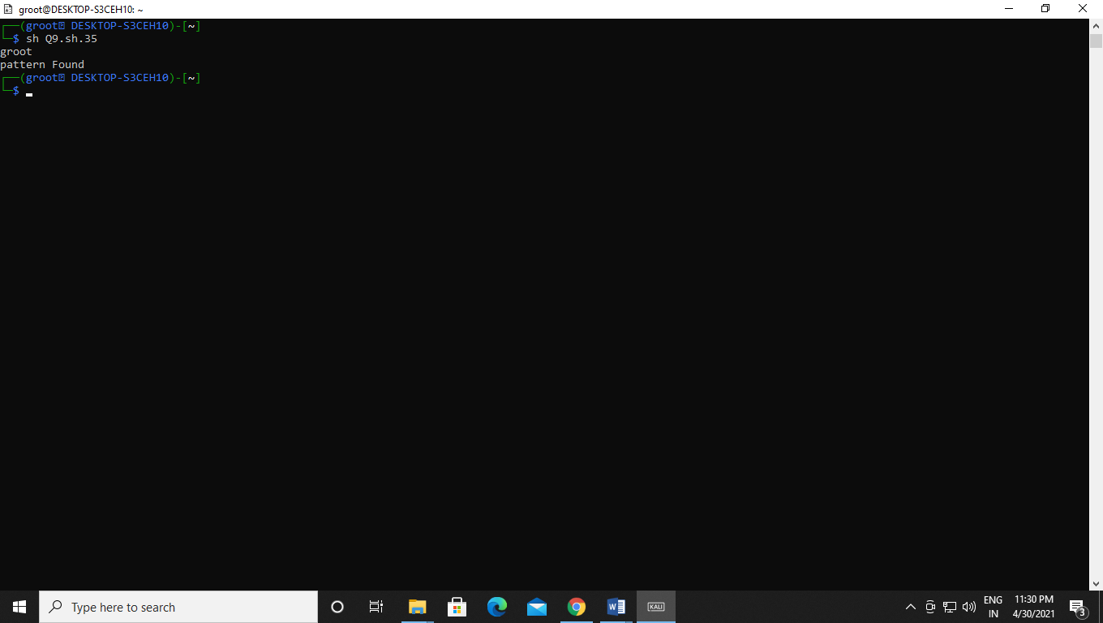

Q10. Write a Shell Script which will redirect the output of the date command without the time into a file.

Code:-

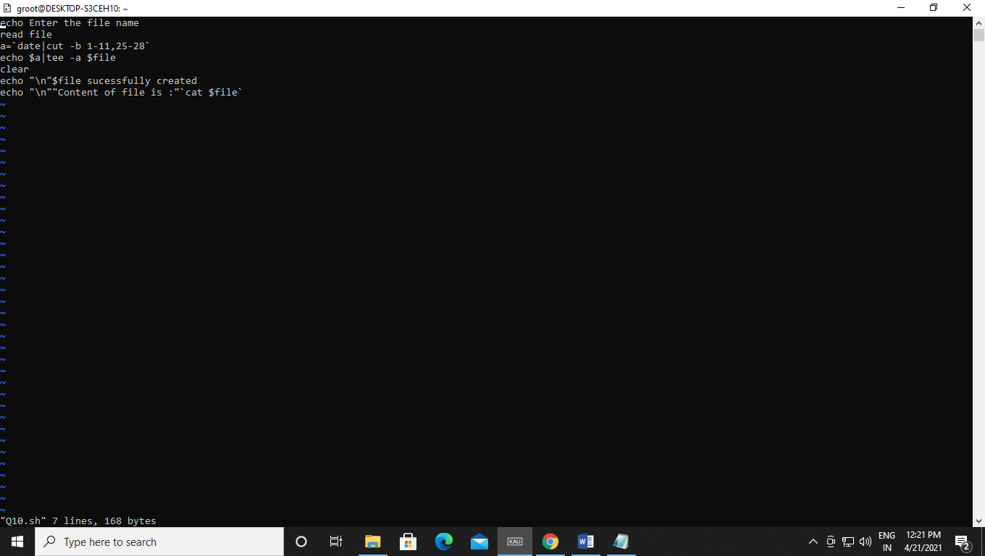Output:-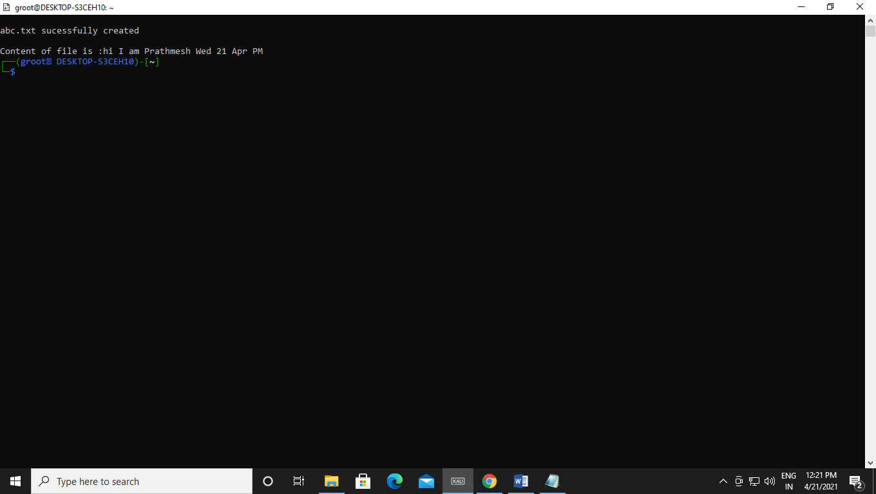

Q11. Write a Shell Script (using while loop) to execute endlessly (until terminatedby user) a loop which displays contents of current directory, disk space status,sleep for 30 seconds and display the users currently logged in on the screen.

Code:-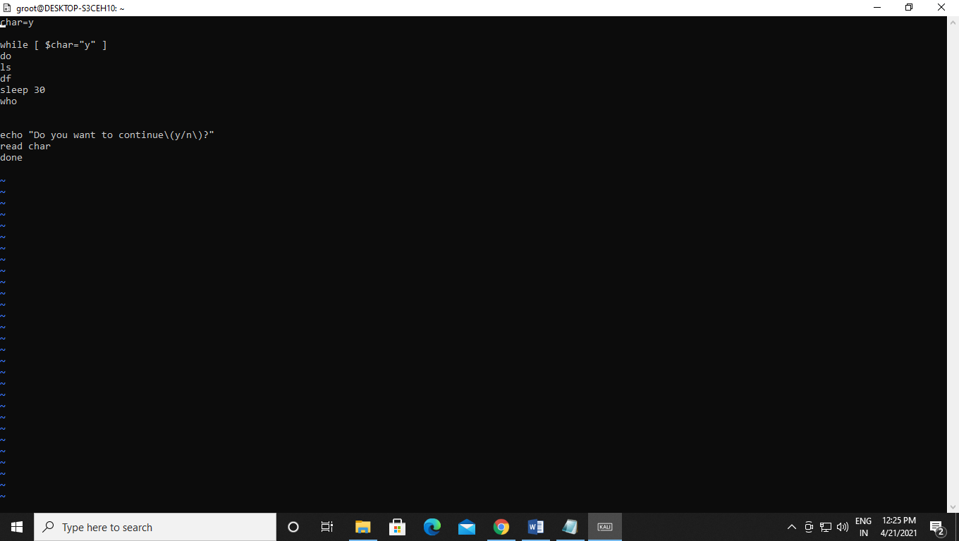Output:- 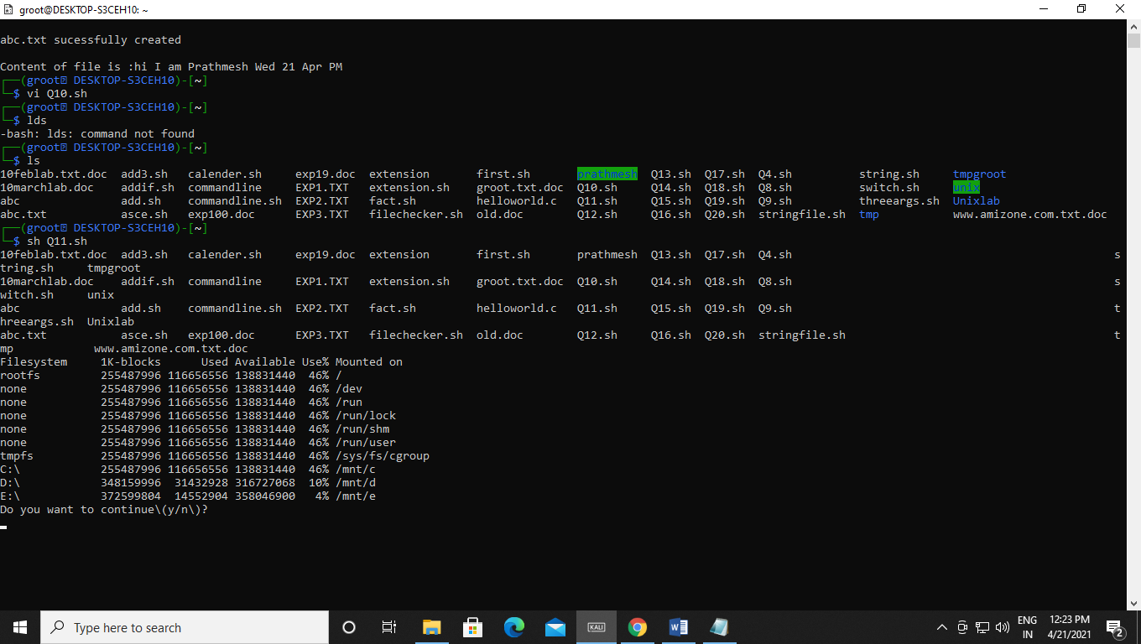

Q12. Write a Shell Script that receives two filenames as arguments. It should check whether content of the two files is same or not. If they are same, second file should be deleted.

Code:-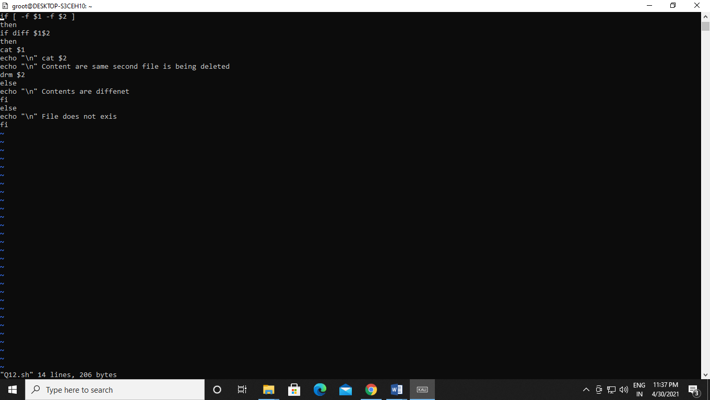Output:-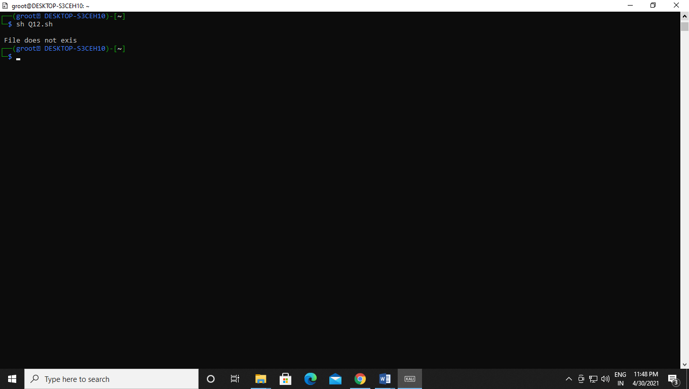

Q13. If a number is input through the keyboard, WASS to calculate sum of its digits.

Code:-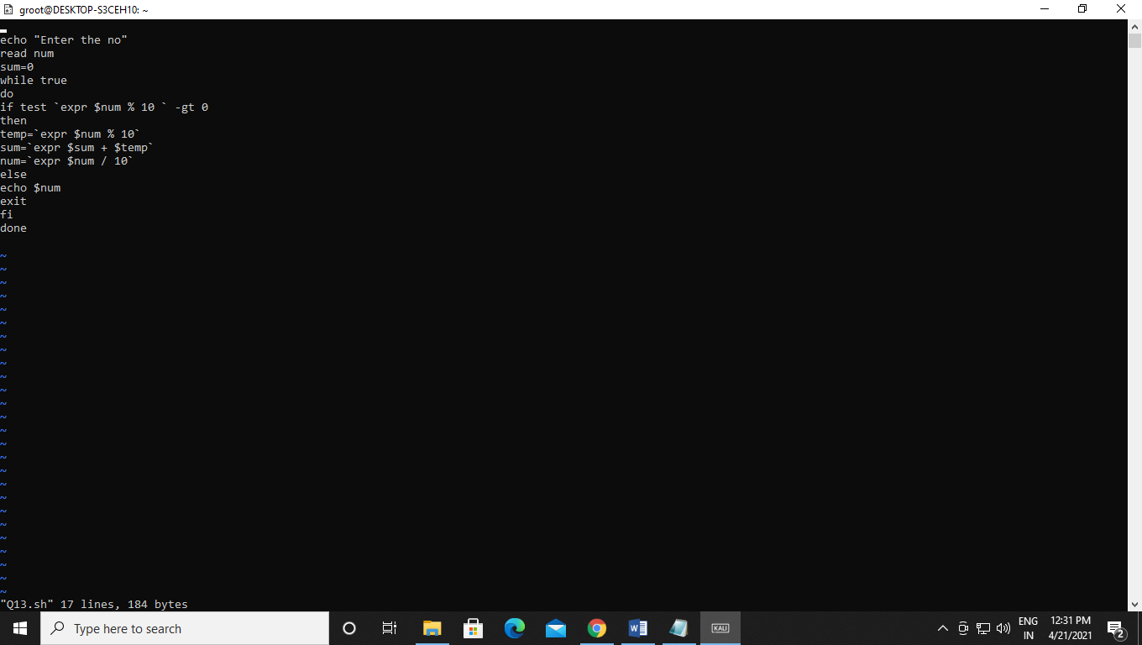Output:-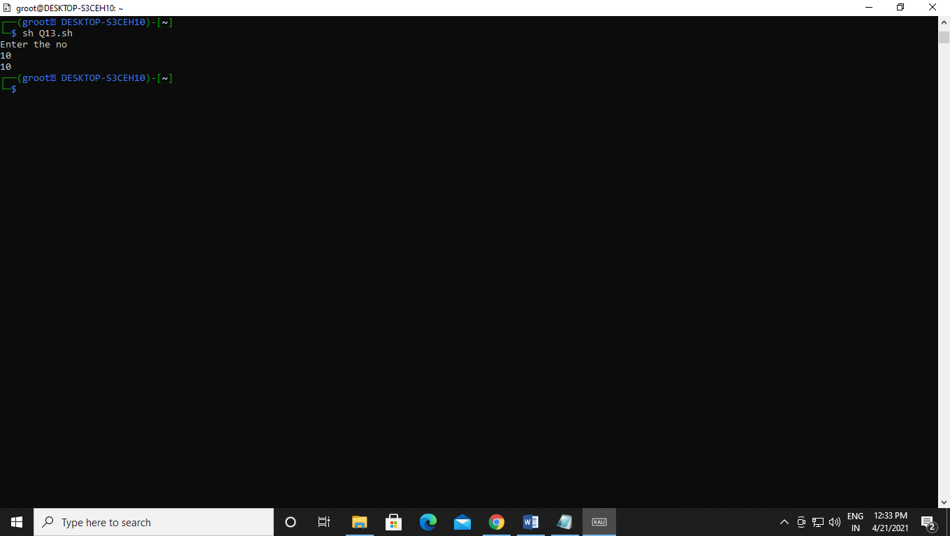

Q14. Write a Shell Script that performs a count-down either from 10 (default) or from the value that is entered by the user.

Code:-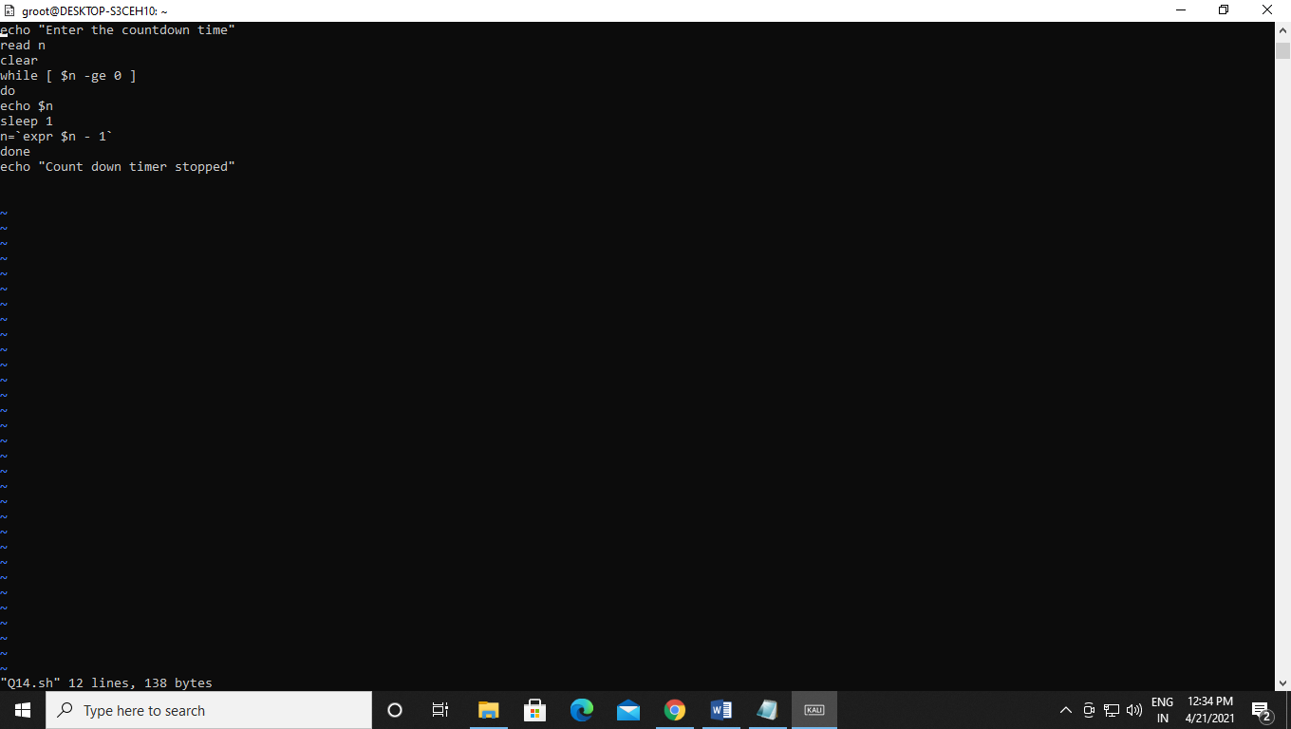Output:-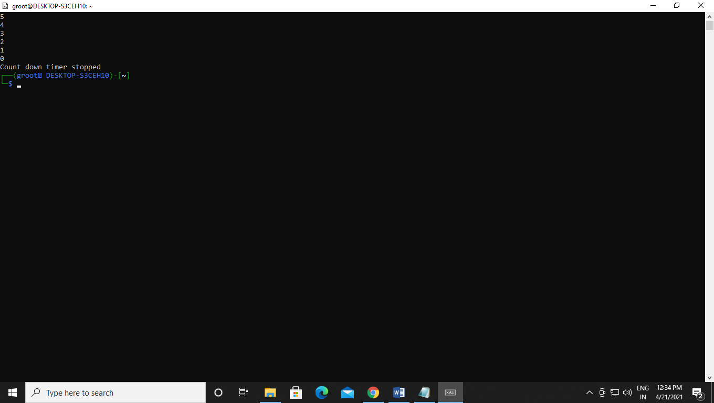

Q15. Write a Shell Script which takes a command line argument of Kms and by default converts that number into meters. Also provide options to convert km to dm and km to cm.

Code:-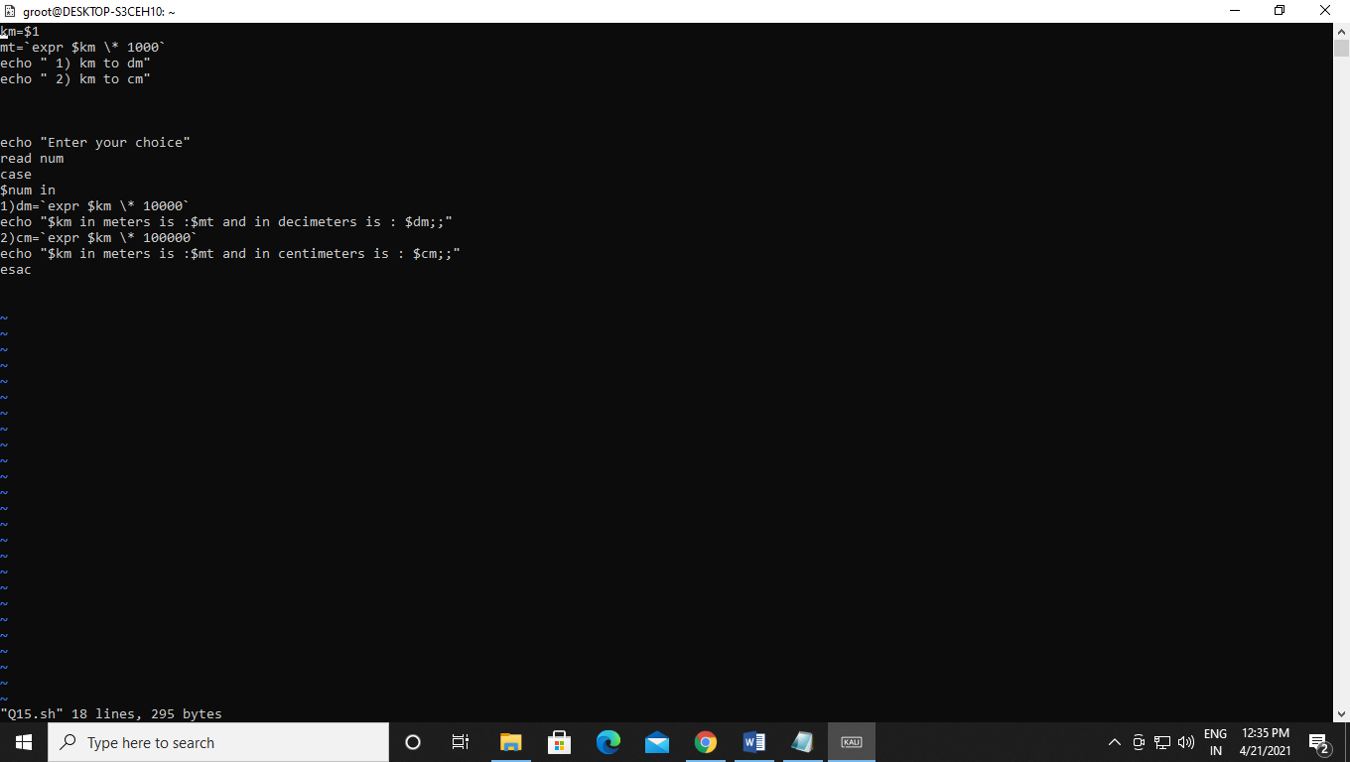Output:-

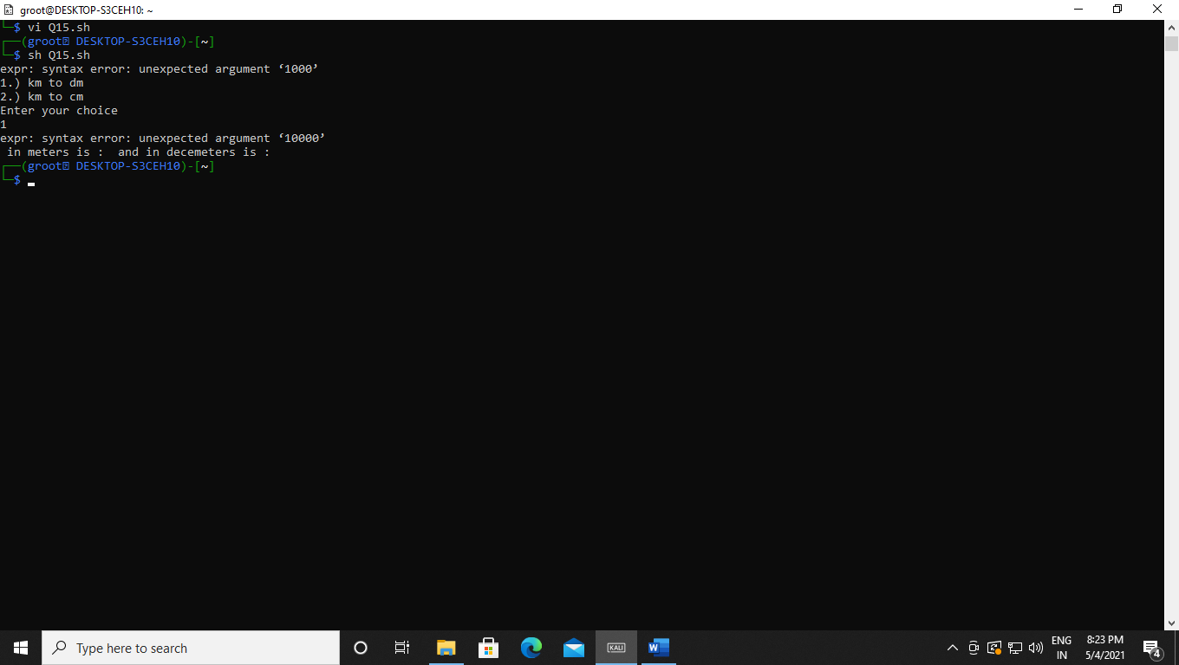

Q16. Write a Shell Script using for loop, which displays the message "Welcome to the UNIX System".

Code:-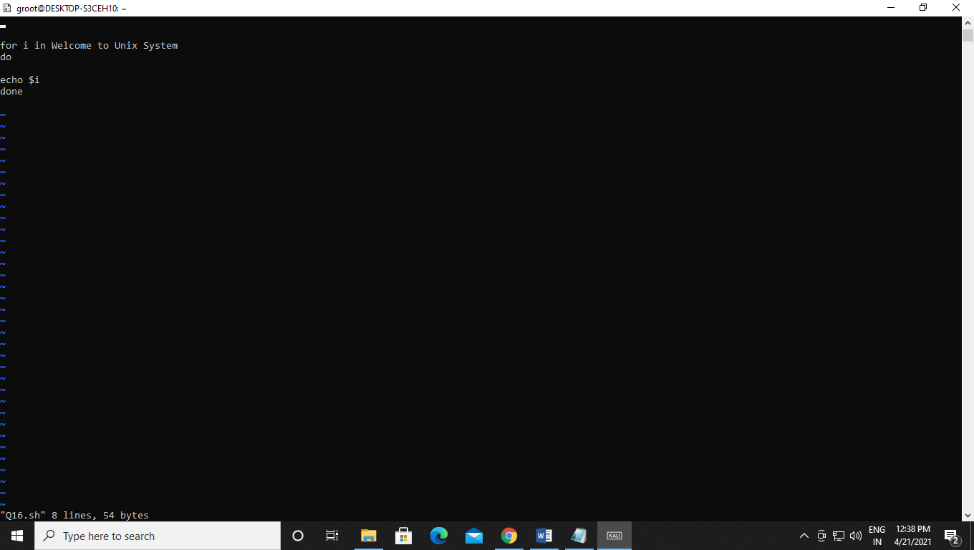Output:-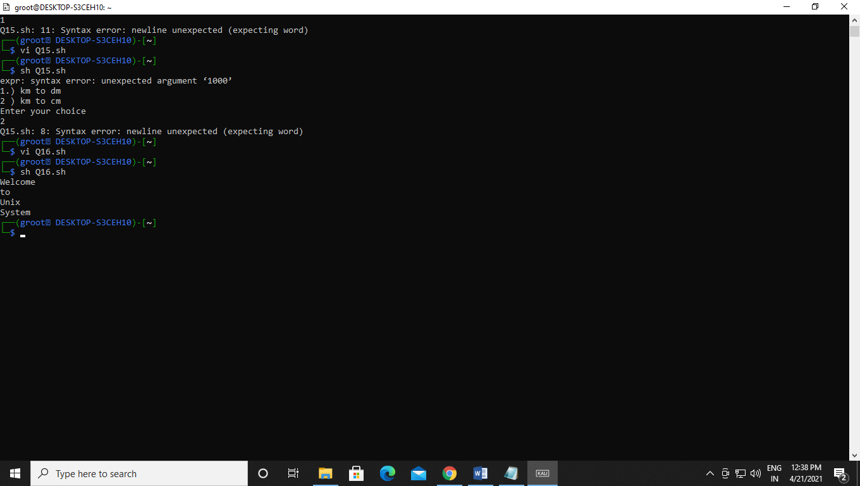

Q17. Write a Shell Script to change the filename of all files in a directory from lower-case to upper-case.

Code:-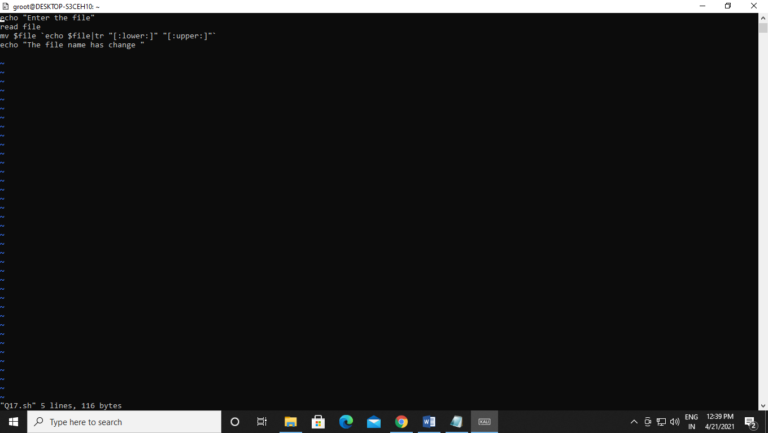Output:-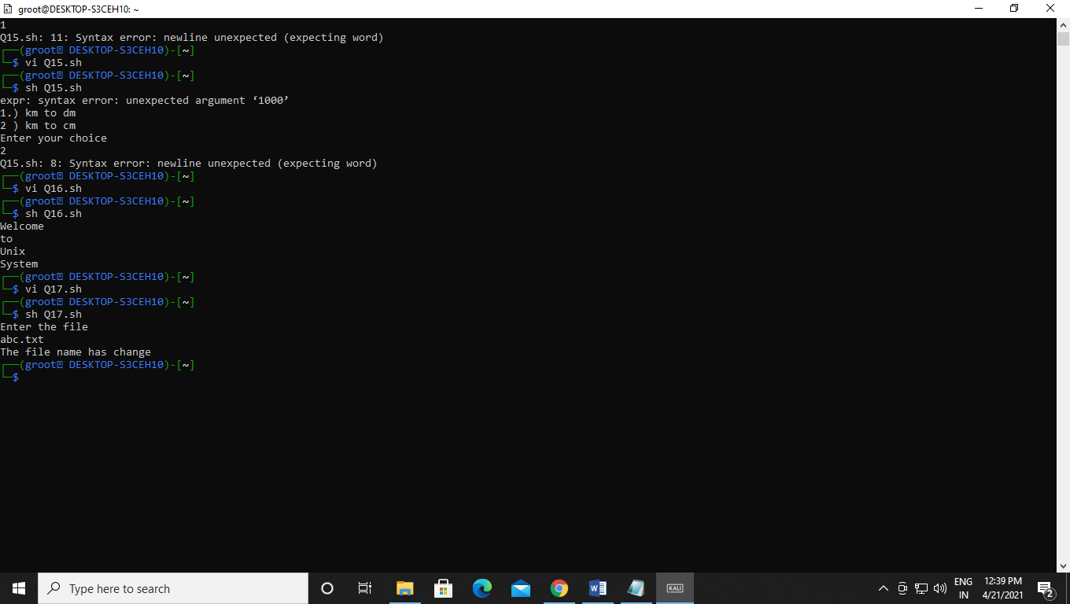

Q18. Write a Shell Script that examines each file in the current directory. Files whose names end in old are moved to a directory named old files and files whose names end in .c are moved to directory named c programs.

Code:-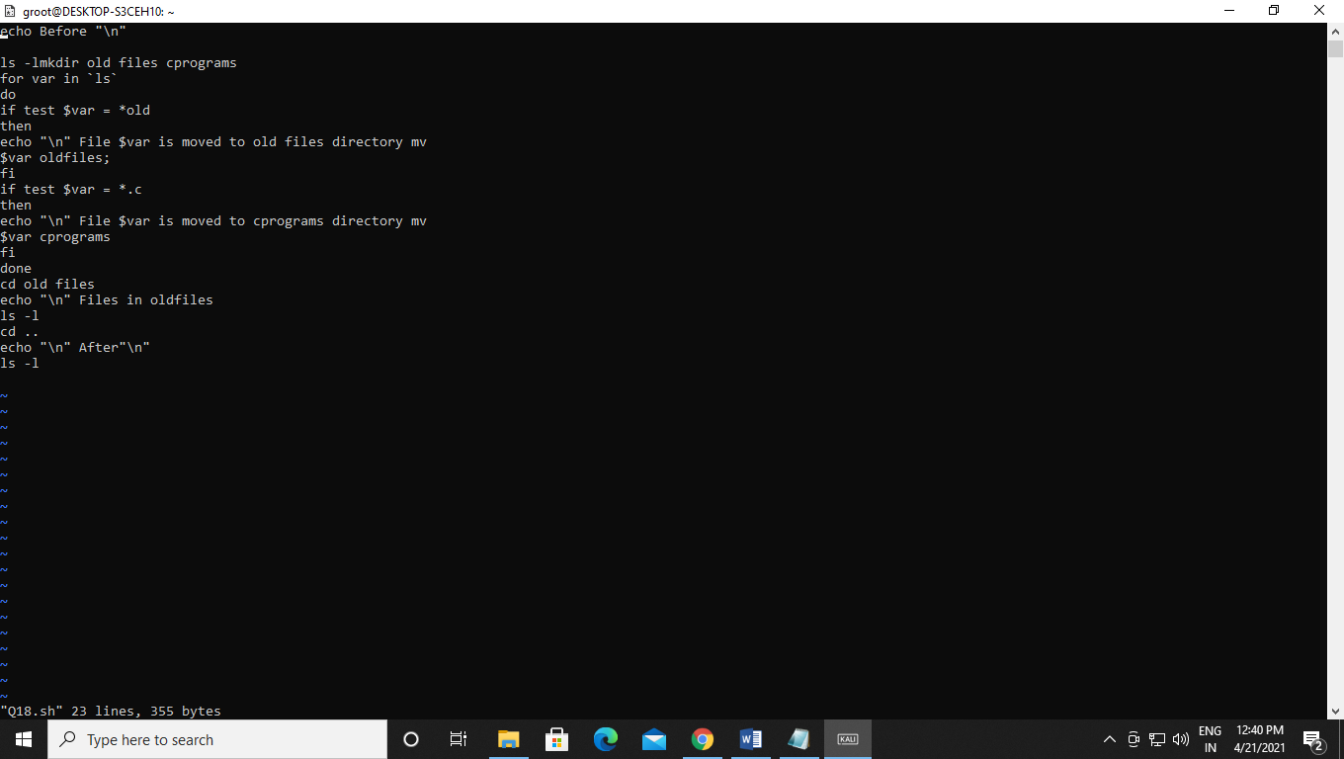Output:- 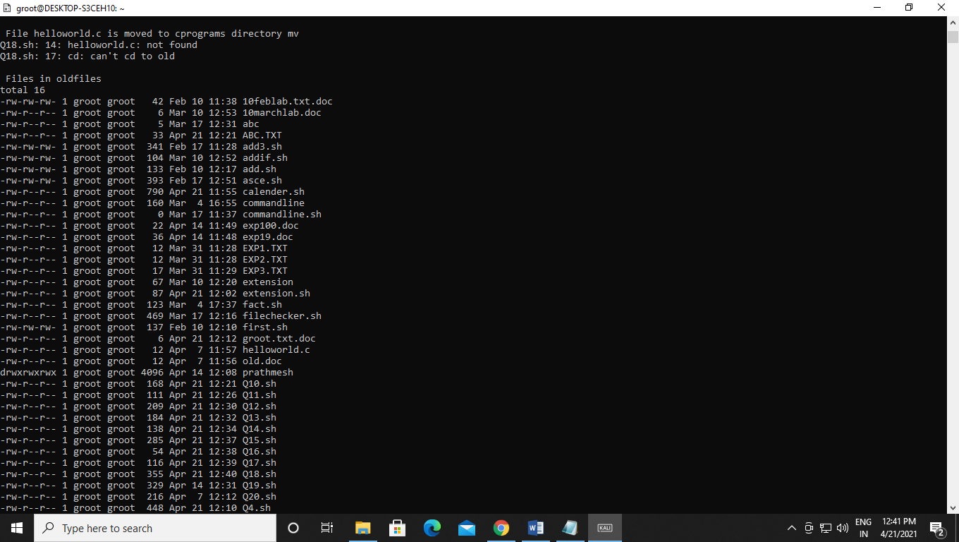

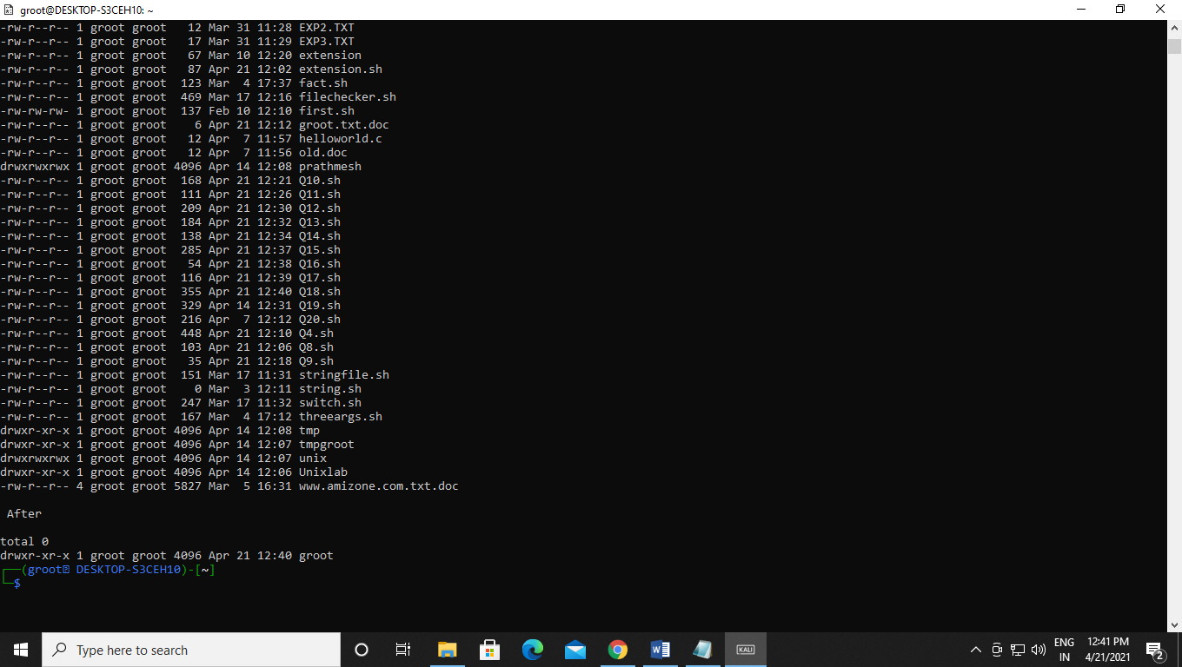

Q19. Write a Shell Script which searches all files in the given directory (to be taken as command line argument) for the file having the title (to be taken as command line argument), as the first line in the file.a) Display the contents of the searched file.b) In the end, print the the file is ###, where### is small-sized if total no. of lines is <50### is medium-sized if total no. of lines between 50&100 ### is large-sized.

Code:- 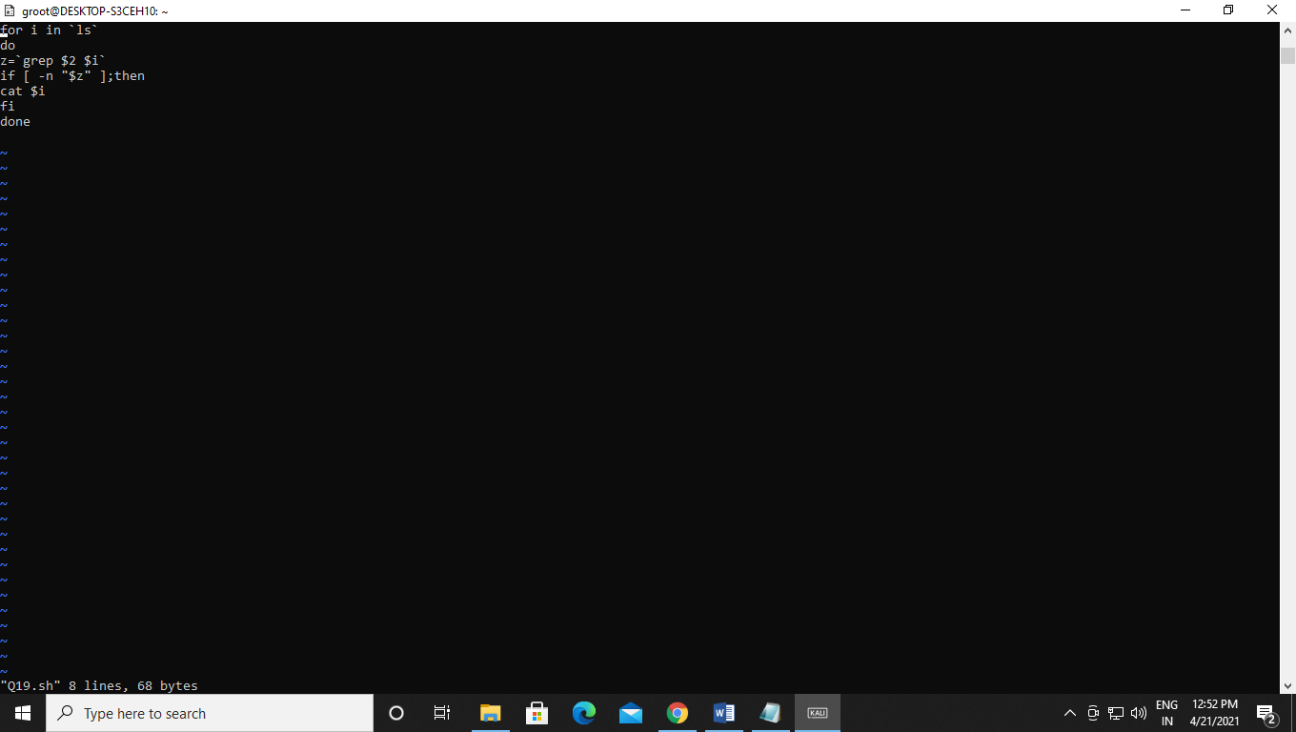Output:- 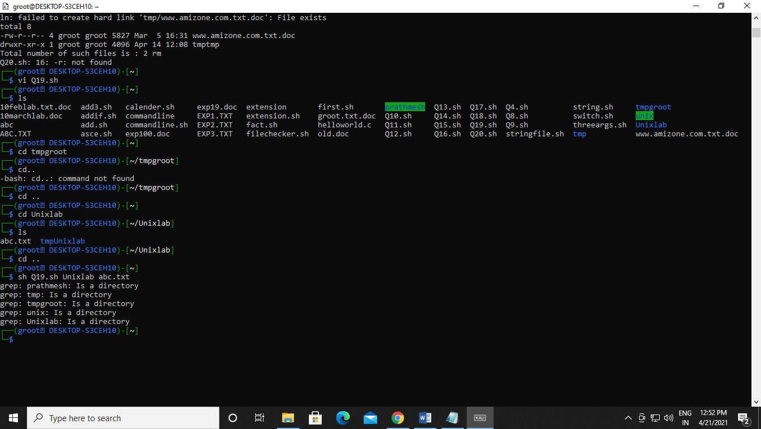Q20. Write a shell script which reports names and sizes of all files in a directory(directory would be supplied as an argument to the shell script) whose size isexceeding 1000 bytes. The filenames should be printed in descending order of their sizes. The total number of such files should also be reported.

Code:- 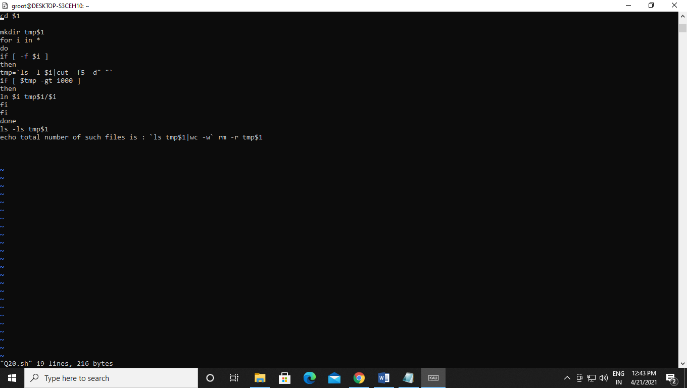Output:- 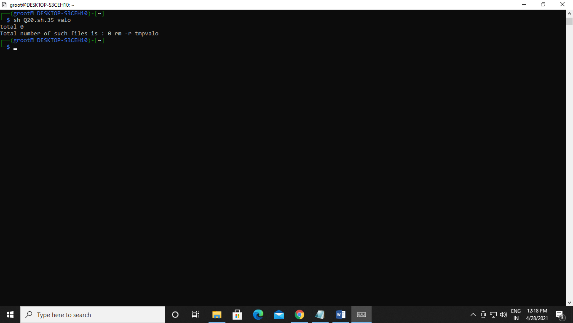Q21 WASS for renaming each file in the directory such that it will have the current shellPID as an extension. The shell script should ensure that the directories do not get renamed

Code:-

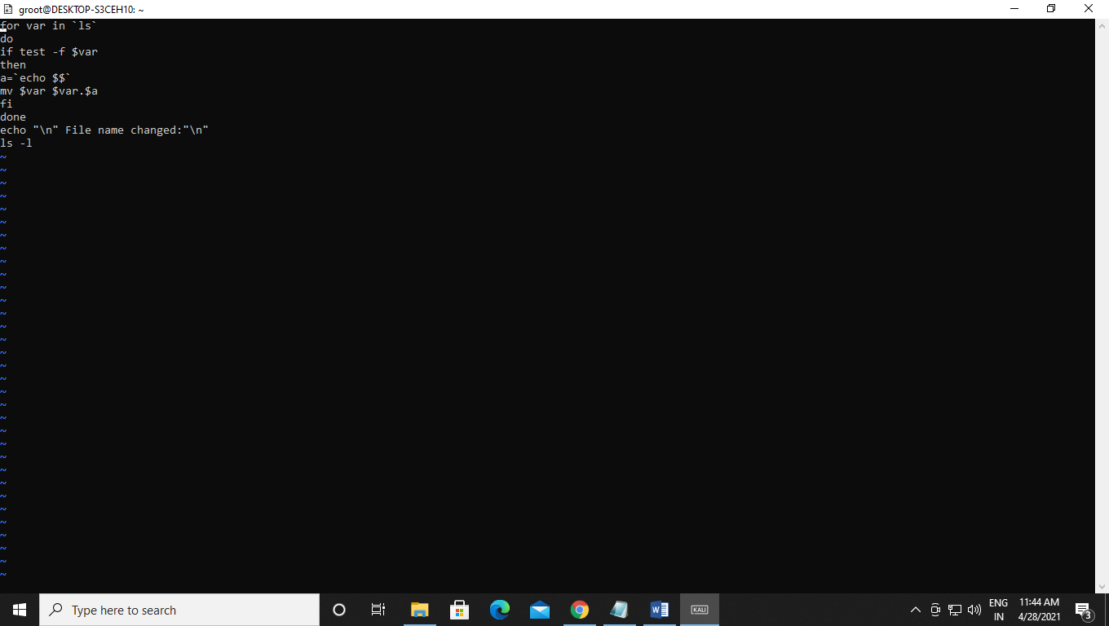Output:-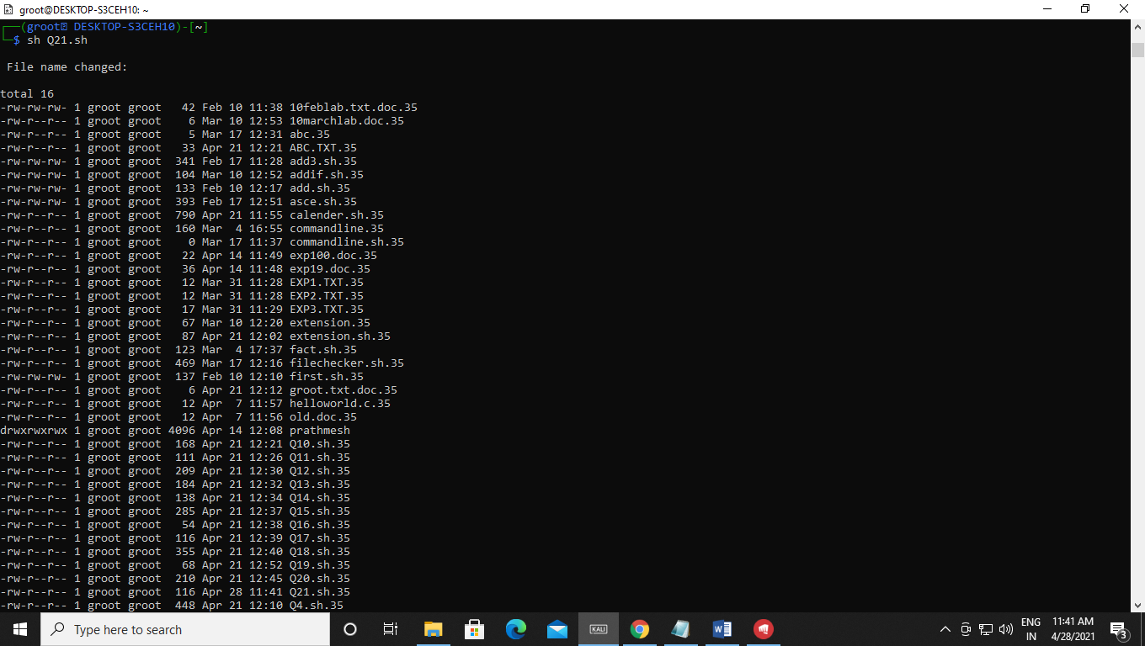

Q22 WAP to calculate and print the first m Fibonacci numbers.

Code:-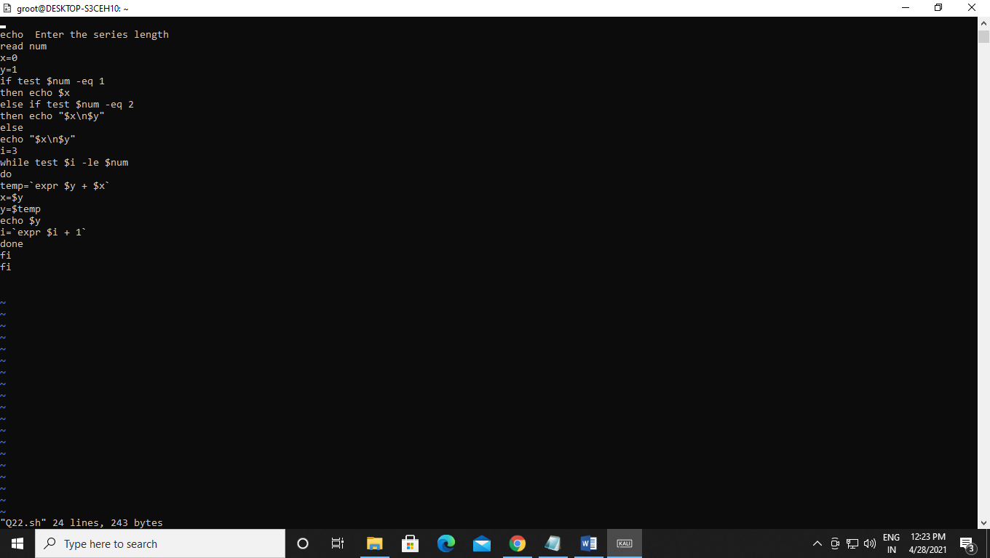Output:-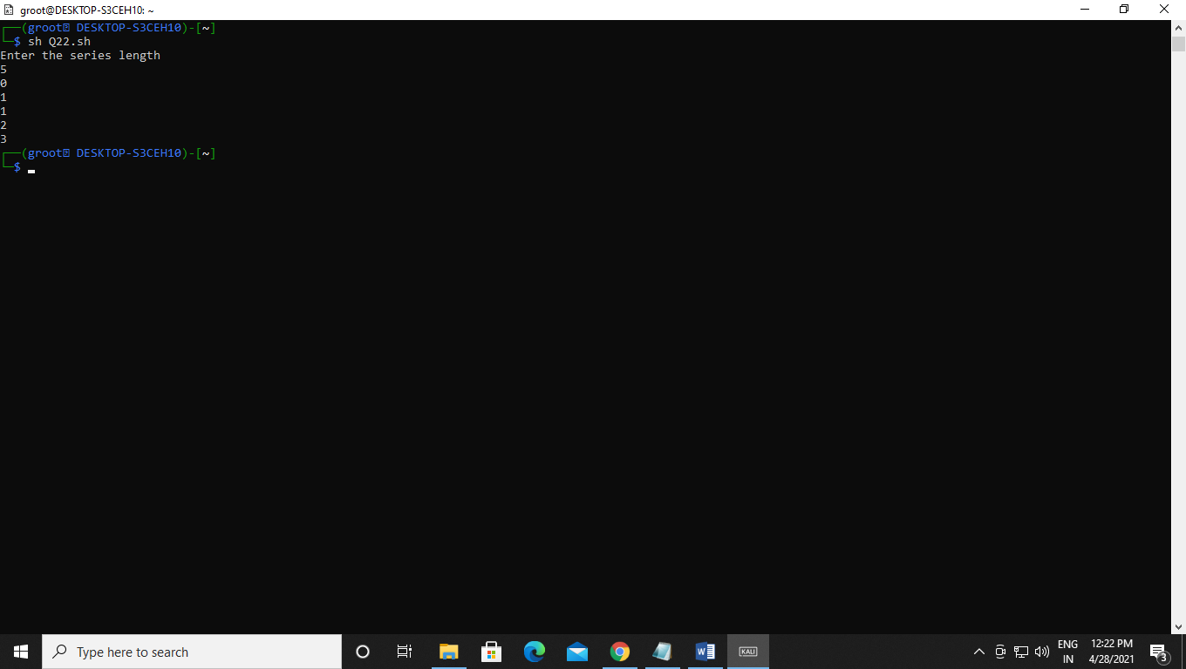

Q23 WASS that will receive any number of filenames as arguments. The shell script should check whether such files already exist. If they do, then it should be reported. The files that do not exist should be created in a sub-directory called mydir. The shell script should first check whether the sub-directory mydir exists in the current directory. If it doesn’t exist, then it should be created. If mydir already exists, then it should be reported along with the number of files that are currently present in mydir.

Output:-

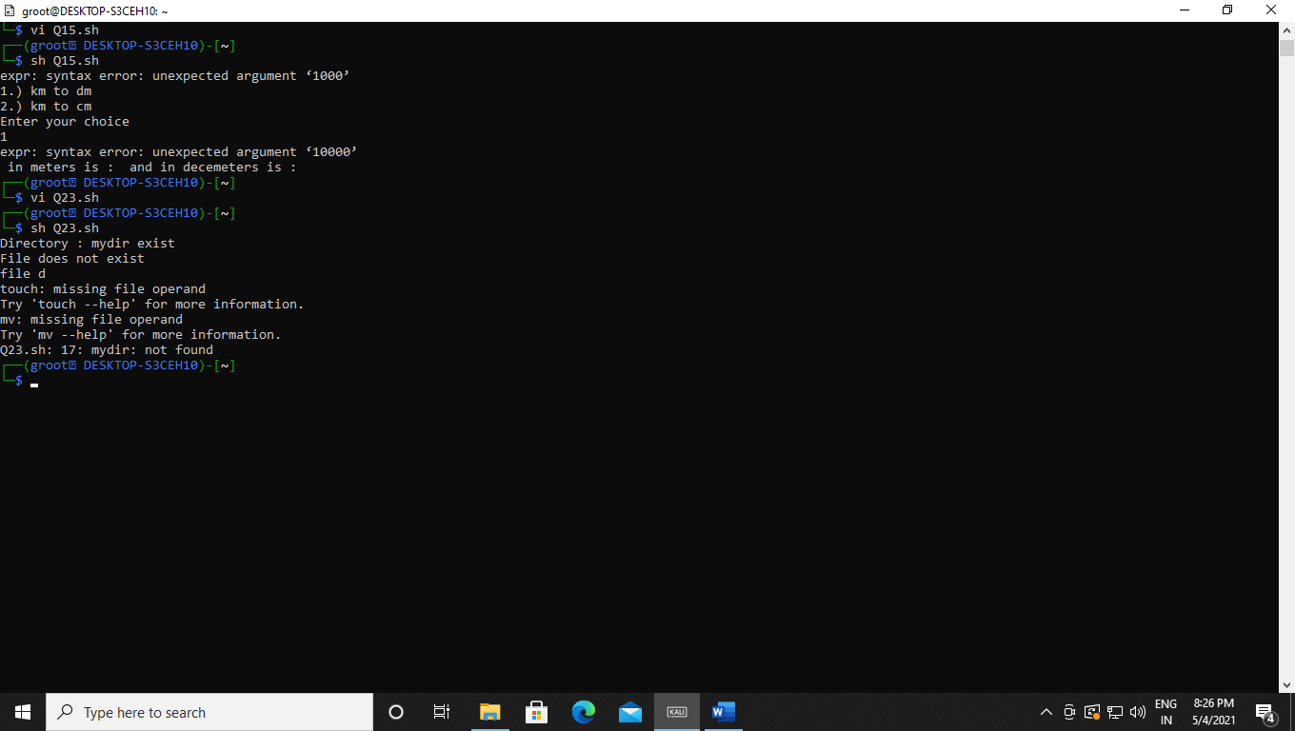

Q24 A shell script receives even number of filenames. Suppose four filenames are supplied, then the first file should get copied into second file, the third file should get copied into fourth and so on. If odd number of filenames is supplied then no copying should take place and an error message should be displayed.

Code:-

Output:-

Q25 WASS to identify all zero-byte files in the current directory and delete them. Before proceeding with deletion, the shell script should get a conformation from the user.

Code:-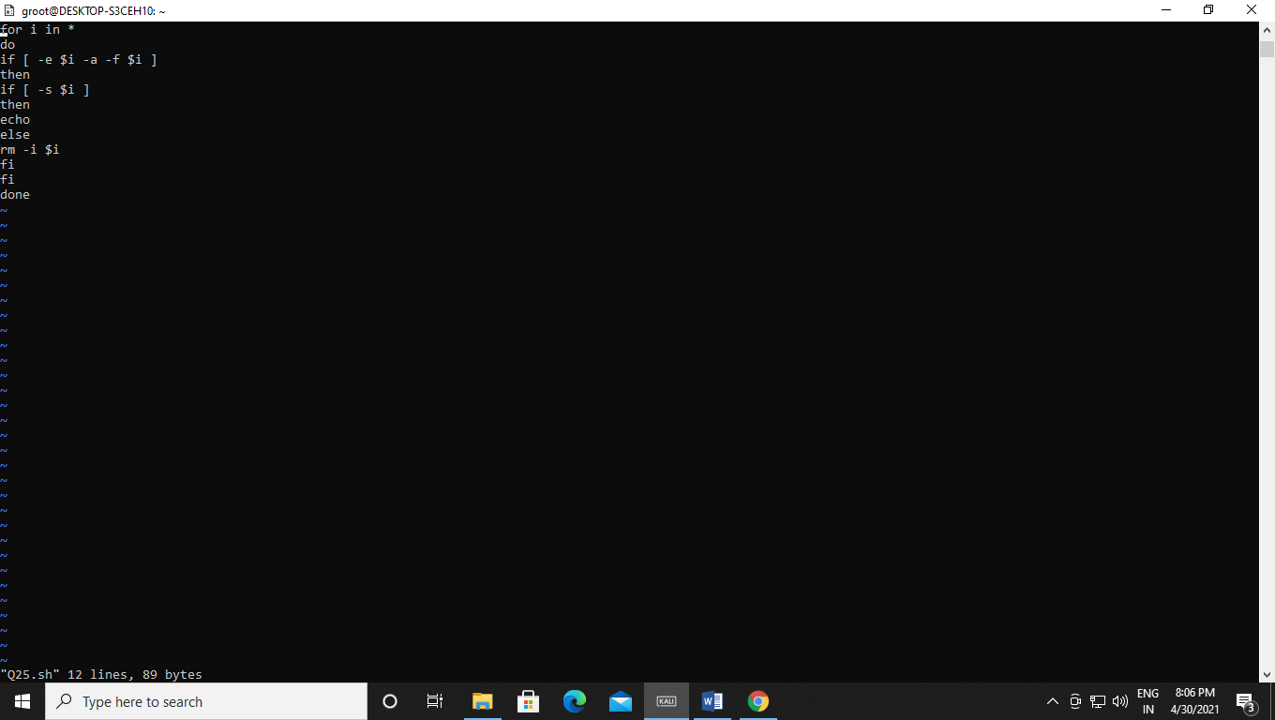Output:- Before deleting 0 byte file:-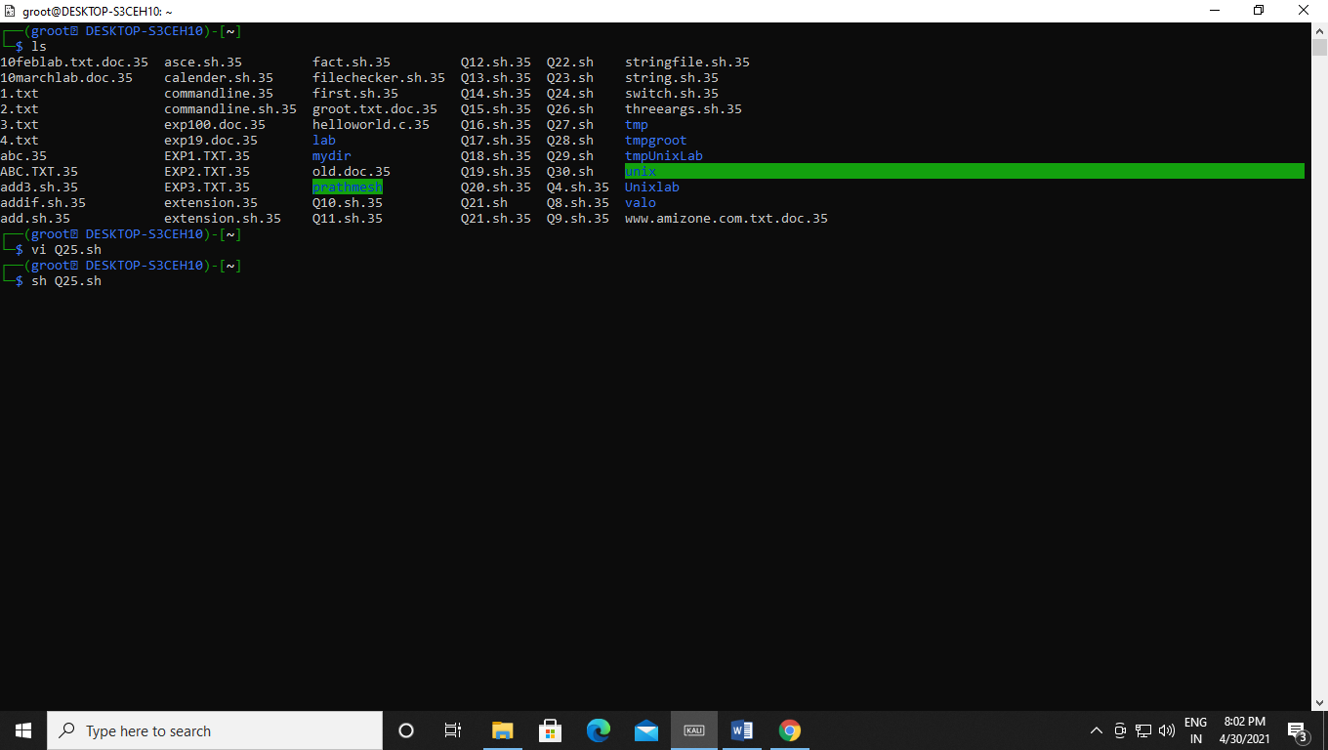

After deleting 0 byte file:-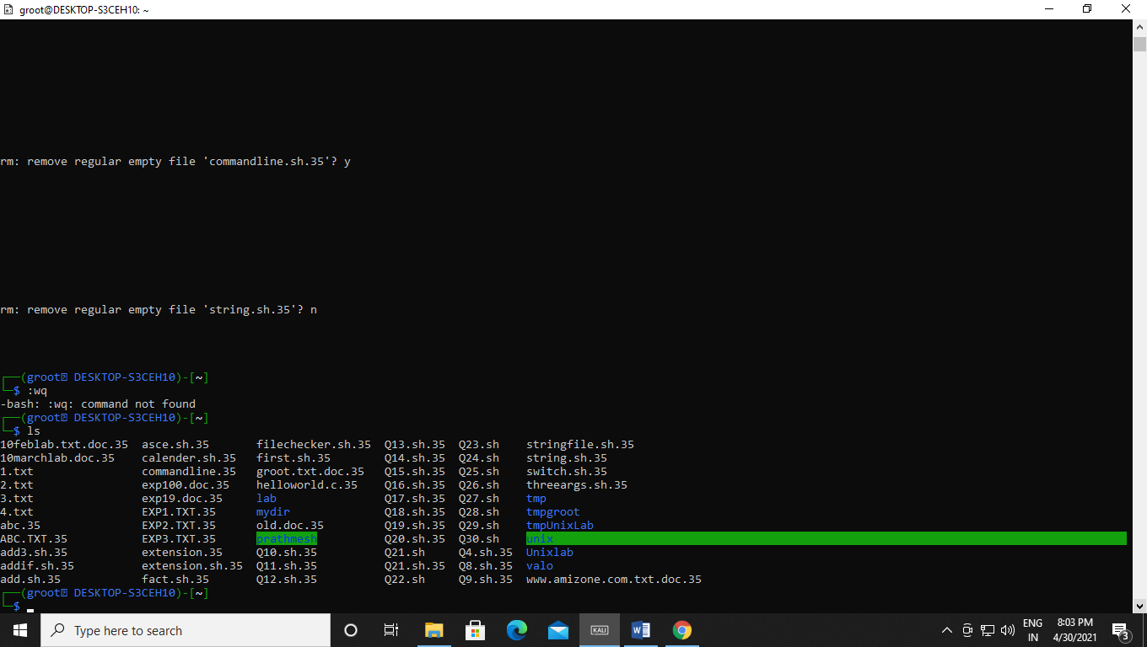

Q26 WASS to compute the GCD and LCM of two numbers.

Code:-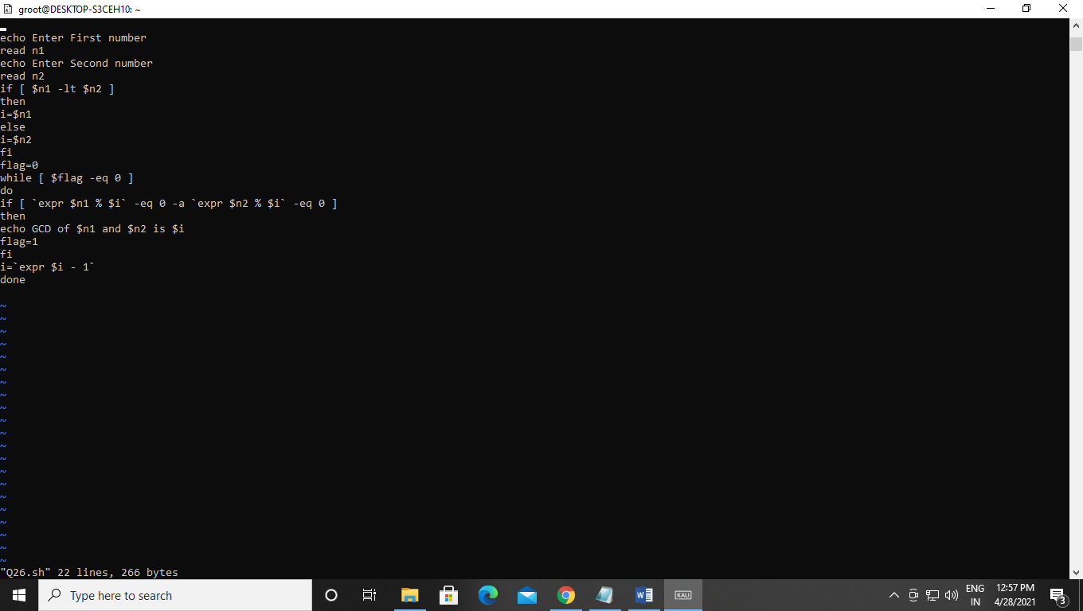Output:-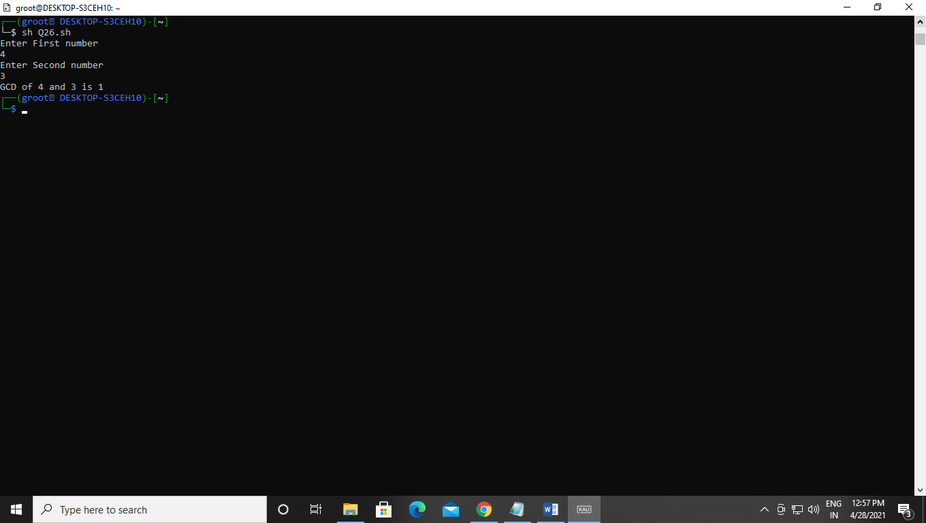

Q27 Two numbers are entered through the keyboard. WAP to find the value of one number raised to the power of another.

Code:-

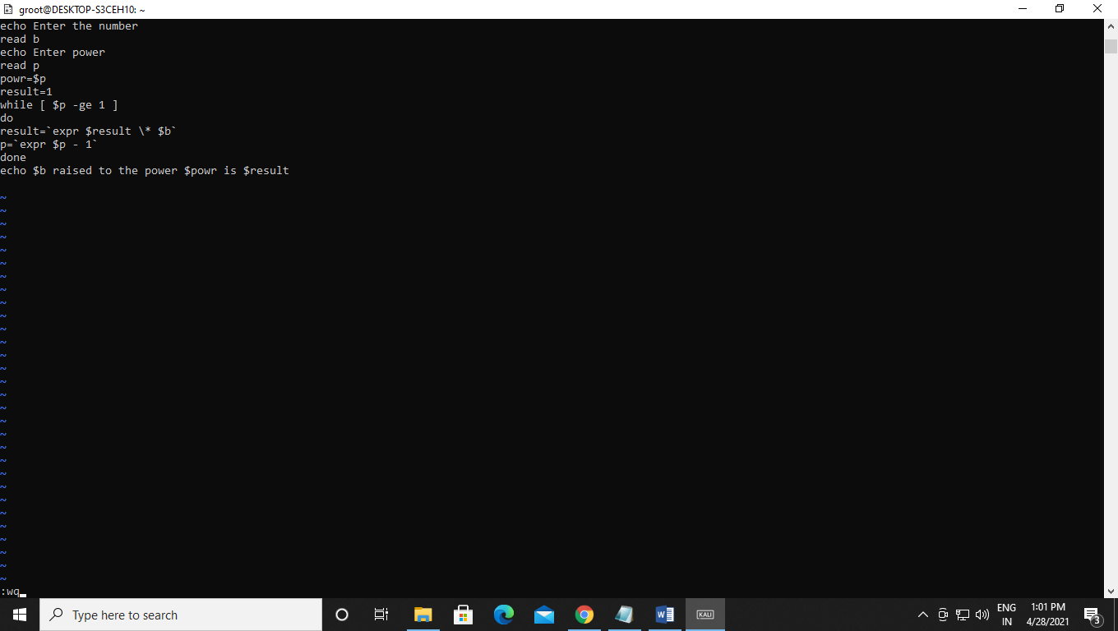Output:-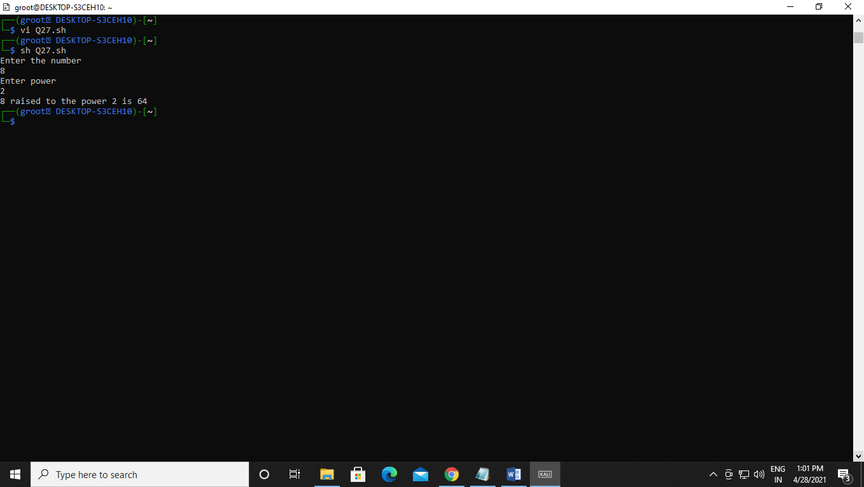

Q28 WASS that prompts the user for the password. The user has maximum of 3attempts. If the user enters the correct password, the message “CorrectPassword” is displayed else the message “Wrong Password”.

Code:-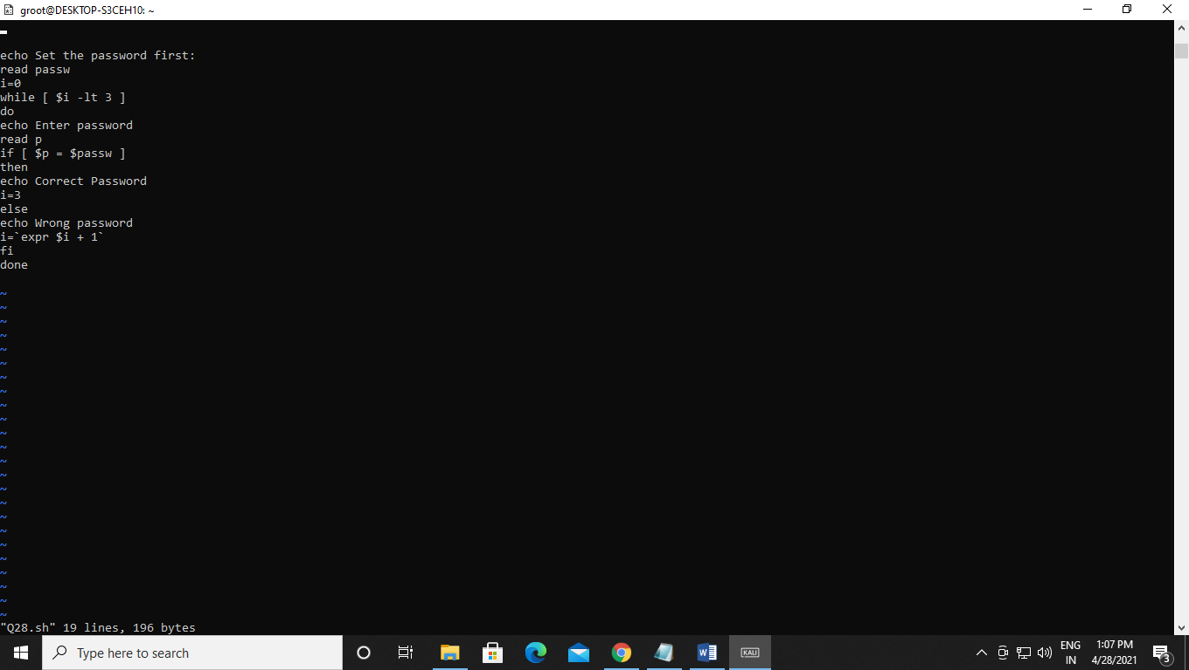Output:-

First 3 attempts:-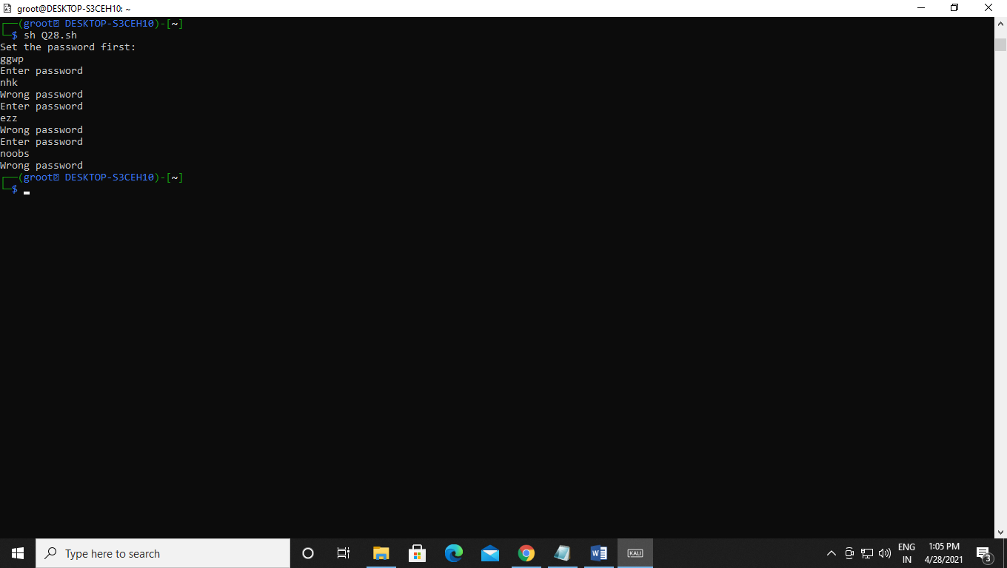Correct password:-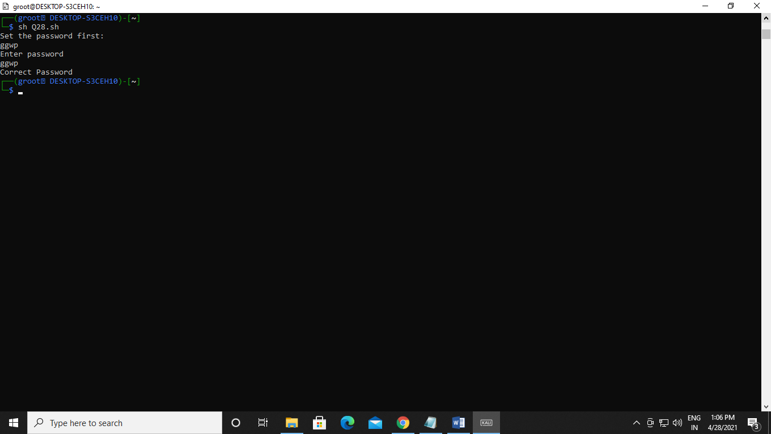

Q29 WASS that repeatedly asks the user repeatedly for the “Name of the Institution” until the user gives the correct answer.

Code:-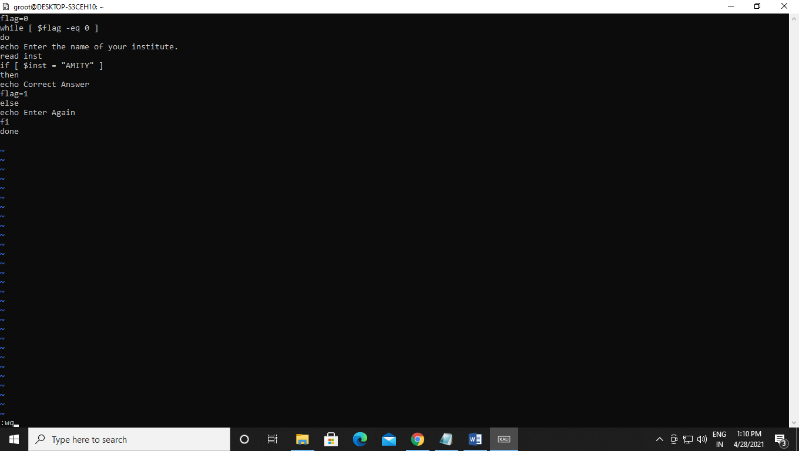Output:-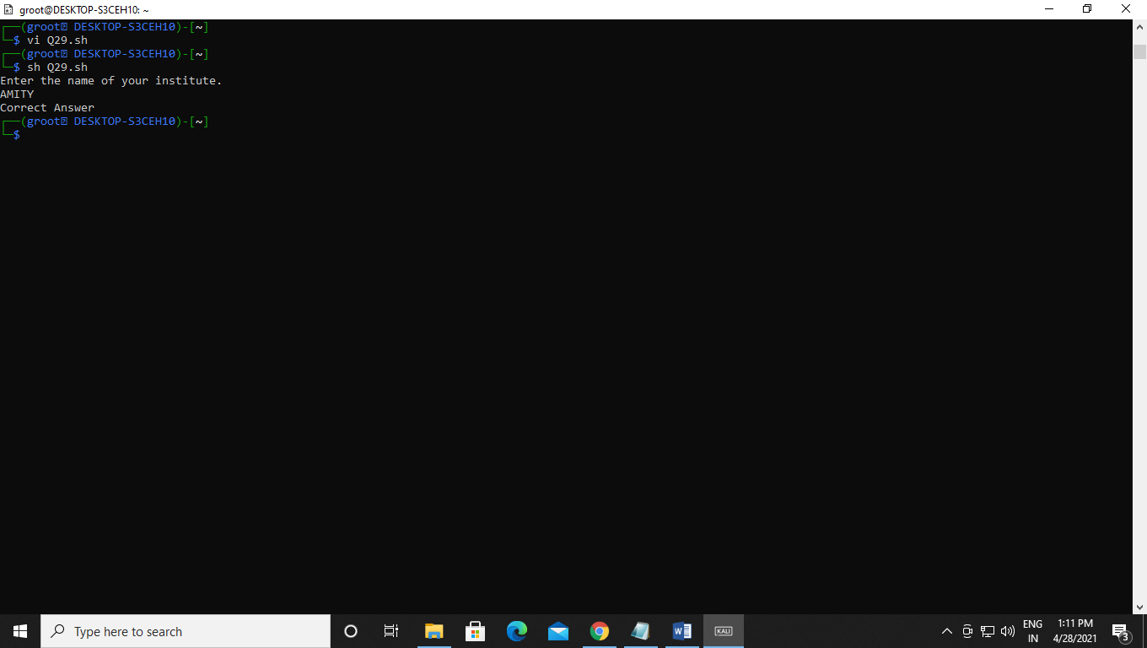

Q30 WAP to generate all combinations of 1, 2 and 3 using for loop.

Code:-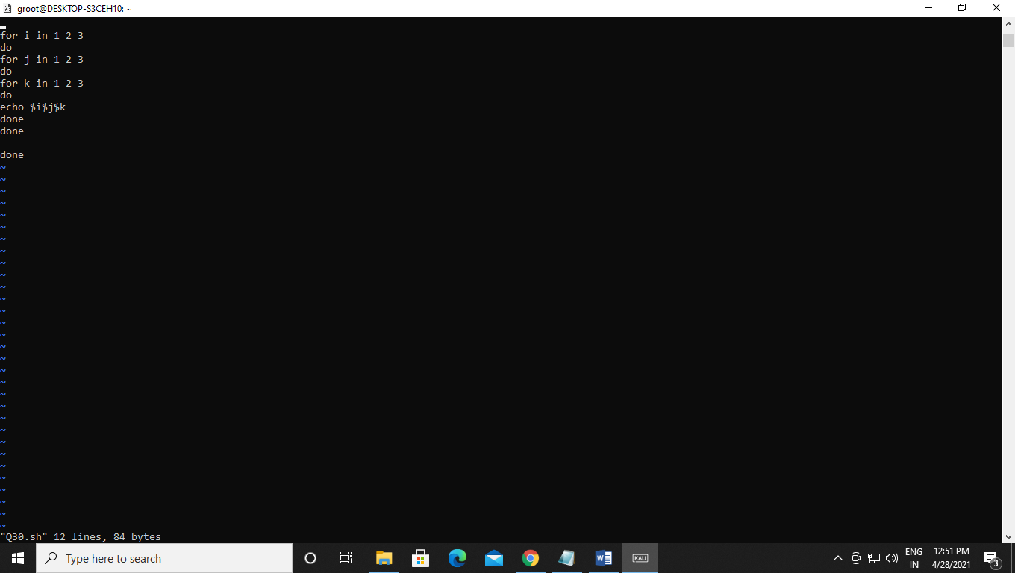Output:-